Name

Mathematics Extension 1 Year 12
Further Derivatives and Integrals

Book 1 |  | Version: 260707  Feedback:  https://MrDingMaths.com
Contents
Syllabus Content 2
Learning Intention 3

Syllabus Content
ME1-12-04 selects and applies differentiation and integration techniques to solve problems
Further derivatives of functions
- Find the derivative of a function defined parametrically using the chain rule
- Solve problems involving derivatives of functions defined parametrically
- Verify using the chain rule that the derivative of the inverse function is the reciprocal of the derivative of the function, evaluated at the value of the inverse function, that is $\left(f^{-1}\right)'(x)=\frac{1}{f^{'}\left(f^{-1}\left(x\right)\right)}$
- Solve problems involving derivatives of inverse functions
- Examine the proofs of the derivatives of $\sin^{-1}{x}$, $\cos^{-1}{x}$ and $\tan^{-1}{x}$
- Use the chain rule to show that $\frac{d}{dx}\left[\sin^{-1}{f\left(x\right)}\right]=\frac{f^{'}\left(x\right)}{\sqrt{1-{\left[f\left(x\right)\right]}^{2}}}$, $\frac{d}{dx}\left[\cos^{-1}{f\left(x\right)}\right]=-\frac{f^{'}\left(x\right)}{\sqrt{1-{\left[f\left(x\right)\right]}^{2}}}=-\frac{d}{dx}\left[\sin^{-1}{f\left(x\right)}\right]$ and $\frac{d}{dx}\left[\tan^{-1}{f\left(x\right)}\right]=\frac{f^{'}(x)}{1+{\left[f\left(x\right)\right]}^{2}}$ and apply the results to solve problems involving derivatives of $\sin^{-1}{f\left(x\right)}$, $\cos^{-1}{f\left(x\right)}$ and $\tan^{-1}{f\left(x\right)}$
- Apply the product, quotient and chain rules to find derivatives of functions of the form $f\left(x\right)g\left(x\right),\frac{f(x)}{g(x)}$ and $f\left(g\left(x\right)\right)$ where $f(x)$ and $g(x)$ are any of the functions covered in the scope of the Mathematics Advanced 11–12 Syllabus (2024) or inverse trigonometric functions and solve related problems
Techniques of integration
- Find indefinite and definite integrals of involving expressions of the form $\frac{1}{\sqrt{a^{2}-x^{2}}}$ or $\frac{a}{a^{2}+x^{2}}$
- Use integration by substitution to evaluate definite and indefinite integrals given the substitution, where the substitution is expressed as a function of the variable of integration or where the variable of integration is the subject of the substitution
- Prove and use the identities $\sin^{2}nx=\frac{1}{2}\left(1-\cos{2nx}\right)$ and $\cos^{2}nx=\frac{1}{2}(1+\cos{2nx})$ to find integrals involving $∫\sin^{2}nx dx$ and $∫\cos^{2}nx dx$

Derivative of Inverse Functions

- Review
- Differentiate a polynomial
- Find $f^{'}\left(x\right)$ where  $$f\left(x\right)=2x+5$$ | - Find $f^{'}\left(x\right)$ where  $$f\left(x\right)=7-3x$$ | - Find $f^{'}\left(x\right)$ where  $$f\left(x\right)=x^{3}+2x$$

- Find the inverse function
- Find $f^{-1}\left(x\right)$ where  $$f\left(x\right)=2x+5$$ | - Find $f^{-1}\left(x\right)$ where  $$f\left(x\right)=3x-1$$
- Find $f^{-1}\left(x\right)$ where  $$f\left(x\right)=x^{3}+1$$ | - Find $f^{-1}\left(x\right)$ where  $$f\left(x\right)=\frac{1-3x}{1+x}$$

- Recognise $f^{-1}\left(b\right)=a$ is equivalent to $f\left(a\right)=b$
- Given $f\left(2\right)=7,$ find $f^{-1}\left(7\right)$ | - Given $f\left(3\right)=5,$ find $f^{-1}\left(5\right)$
- Given $f^{-1}\left(4\right)=1,$ find $f\left(1\right)$ | - Given $f^{-1}\left(3\right)=2,$ find $f\left(2\right)$

- Recognise that $f$ and $f^{-1}$ are reflections across $y=x$
- The point (2, 7) lies on $f$. Write down the coordinates of the corresponding point on $f⁻¹$. | - The point (3, 1) lies on $f⁻¹.$ Write down the coordinates of the corresponding point on $f$.

- Investigation Derivative of the inverse function.
- Always use $f\left(x\right)$ and $f^{-1}\left(x\right)$ to refer to your functions.
Using $y=$… can make you lose track.
We will investigate the derivative of inverse functions.
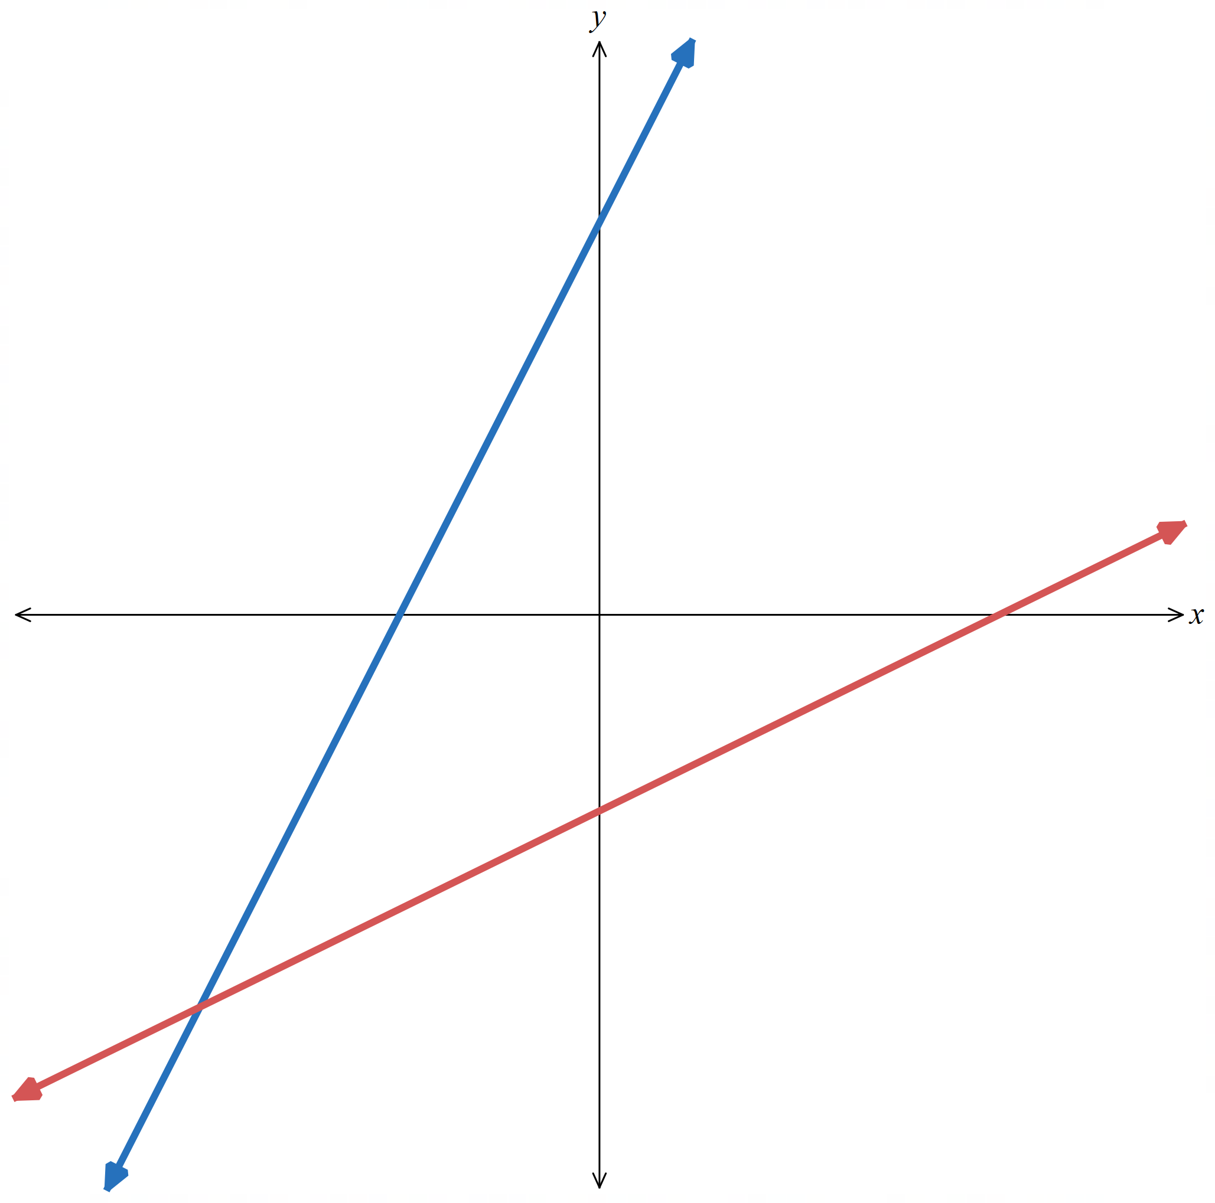
Consider a linear function $f\left(x\right)=2x+5$.
Find the inverse function and write it in terms of $x$.

$$f^{-1}\left(x\right)=$$
Differentiate the inverse function.

$${\left(f^{-1}\right)}^{'}\left(x\right)=$$

What do you notice about the gradient of $f^{-1}\left(x\right)$ compared to the gradient of $f\left(x\right)$?
Explain this in terms of the graph and the general equation $y=mx+c.$
A function and its inverse are …………………… across $y=x$.
We can do this by swapping …… and …… in the equation.

Start with $y=mx+c$
Swapping: ………………
Rearrange for $y$: ………………
The new line’s gradient is: ……………

- Investigation Derivative of the inverse function.
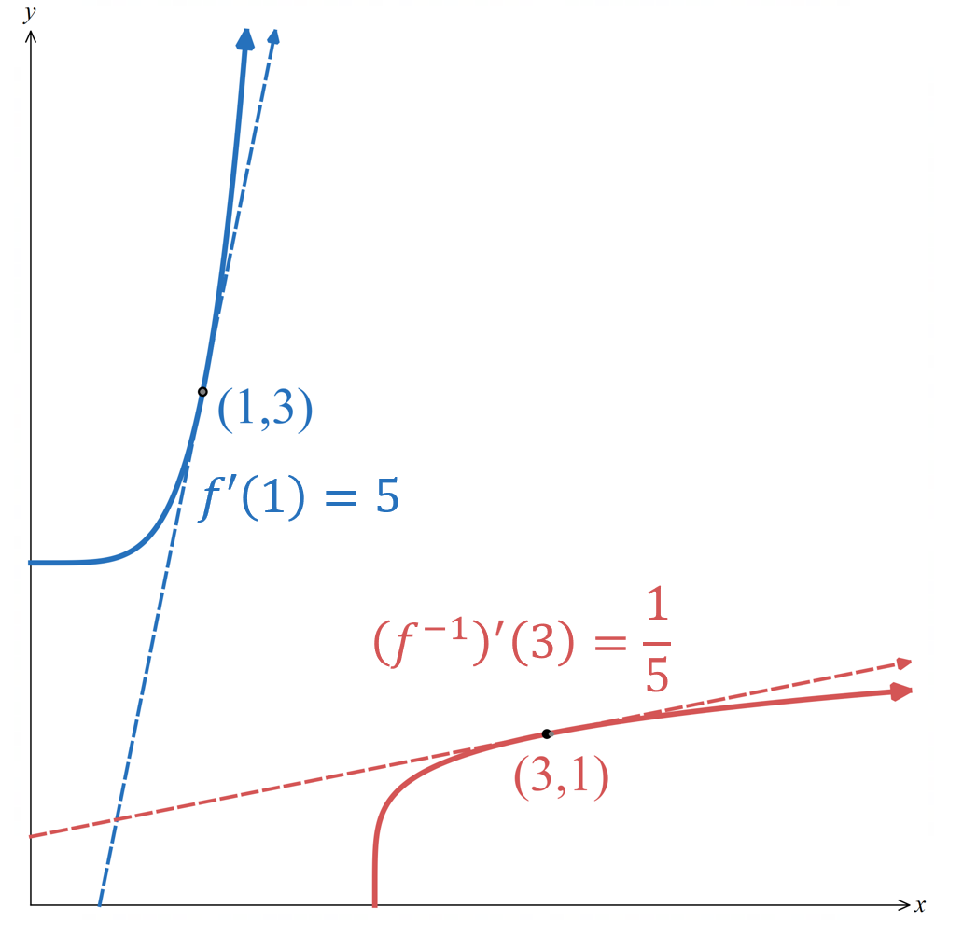
This rule extends beyond linear functions.
Consider $f\left(x\right)=x^{5}+2$.
Show that $f^{-1}\left(x\right)={\left(x-2\right)}^{\frac{1}{5}}$

Hence find ${\left(f^{-1}\right)}^{'}\left(x\right)$

Evaluate $f^{'}\left(x\right)$ at $\left(1,3\right)$

Evaluate ${\left(f^{'}\right)}^{-1}\left(x\right)$ at $\left(3,1\right)$

When a function is reflected across the line $y=x$ to produce its inverse, two things happen:
            - Each point $\left(a,b\right)$ on the original curve maps to $\left(b,a\right)$ on the inverse.
            - The tangent line at that point is also reflected; a line with gradient $m$ reflects to a line with gradient $\frac{1}{m}$. So, the gradient of the tangent is its reciprocal.

This gives the inverse function derivative rule:
For a point $\left(x,y\right)$ on the inverse function:
$${\left(f^{-1}\right)}^{'}\left(x\right)=\frac{1}{f^{'}\left(f^{-1}\left(x\right)\right)}=\frac{1}{f^{'}\left(y\right)}$$
This is useful because you do not need to find an equation for derivative of the inverse function at all!
Example:
For $f\left(x\right)=x^{5}+2$, the gradient of the tangent at the point $\left(3,1\right)$ on the inverse function is:
$${\left(f^{-1}\right)}^{'}\left(3\right)=\frac{1}{f^{'}\left(f^{-1}\left(3\right)\right)} \\ =\frac{1}{f^{'}\left(1\right)} \\ =\frac{1}{5}$$
- Investigation Derivative of the inverse function.
Alternative to
$${\left(f^{-1}\right)}^{'}\left(x\right)=\frac{1}{f^{'}\left(f^{-1}\left(x\right)\right)}=\frac{1}{f^{'}\left(y\right)}$$
is:
$$\frac{dy}{dx}=\frac{1}{\frac{dx}{dy}}$$
Where $\frac{dy}{dx}$ and $\frac{dx}{dy}$ refer to the derivatives of the inverse function ${\left(f^{-1}\right)}^{'}\left(x\right)$ and ${\left(f^{-1}\right)}^{'}\left(y\right)$.
See how this works with $f\left(x\right)=x^{5}+2$.

Using function notation  $$f\left(x\right)=x^{5}+2 \\ y=x^{5}+2 \\ x=y^{5}+2 \\ y^{5}=x-2 \\ y={\left(x-2\right)}^{\frac{1}{5}} \\ f^{-1}\left(x\right)={\left(x-2\right)}^{\frac{1}{5}}$$  $${\left(f^{-1}\right)}^{'}\left(x\right)=\frac{1}{5}{\left(x-2\right)}^{-\frac{4}{5}} \\ =\frac{1}{5{\left(x-2\right)}^{\frac{4}{5}}} \\ =\frac{1}{{5y}^{4}}$$ | Using $\frac{dy}{dx}$ notation  $$y=x^{5}+2$$  $$x=y^{5}+2$$  $$\frac{dy}{dx}=\frac{1}{\left(\frac{dx}{dy}\right)} \\ =\frac{1}{5y^{4}}$$  $$=\frac{1}{5{\left(x-2\right)}^{\frac{4}{5}}}$$  The $y$ refers to your inverse function, not your original.  The $\frac{dy}{dx}$ and $\frac{dx}{dy}$ in the formula refers to the inverse, after you have swapped $x$ and $y!$
- Mr Ding recommends using function notation.
All HSC questions so far have always used function notation.

- Derivative of Inverse Functions
For a point $\left(x,y\right)$ on the inverse function:
$${\left(f^{-1}\right)}^{'}\left(x\right)=\frac{1}{f^{'}\left(f^{-1}\left(x\right)\right)} \\ =\frac{1}{f^{'}\left(y\right)}$$

- Example Differentiate inverse function
- $f\left(x\right)=x^{3}-1.$ Find the derivative of the inverse function.
- Find the gradient of the tangent to the inverse function at $\left(7,2\right)$.
a)  $$f\left(x\right)=y=x^{3}-1 \\ x=y^{3}-1 \\ y^{3}=x+1 \\ f^{-1}\left(x\right)={\left(x+1\right)}^{\frac{1}{3}} \\ {\left(f^{-1}\right)}^{'}\left(x\right)=\frac{1}{3}{\left(x+1\right)}^{-\frac{2}{3}}$$ | b) We can use result of (a) or the formula.  $${\left(f^{-1}\right)}^{'}\left(7\right)=\frac{1}{3}{\left(7+1\right)}^{-\frac{2}{3}}=\frac{1}{12} \\ OR {\left(f^{-1}\right)}^{'}\left(7\right)=\frac{1}{f^{'}\left(f^{-1}\left(7\right)\right)} \\ {\left(f^{-1}\right)}^{'}\left(7\right)=\frac{1}{f^{'}\left(2\right)} \\ =\frac{1}{3{\left(2\right)}^{2}} using f^{'}\left(x\right)=3x^{2} \\ =\frac{1}{12}$$  Note: it was possible to do part (b) without (a)

- Guided Practice
- $f\left(x\right)=\sqrt{x-3}$. Find the derivative of the inverse function.
Find the gradient of the tangent to the inverse function at $\left(3,12\right)$ using two methods.

$${\left(f^{-1}\right)}^{'}\left(x\right)=2x, {\left(f^{-1}\right)}^{'}\left(3\right)=6$$
- Let $f\left(x\right)=x^{3}+2x$. Find the gradient of the tangent to the inverse function at $\left(12,2\right).$

$$\frac{1}{14}$$

Foundation
- Differentiate f⁻¹(x) given:
- $f\left(x\right)= e^{x}$  $$f^{-1}\left(x\right)=\ln{x}$$  $${\left(f^{-1}\right)}^{'}\left(x\right)=\frac{1}{x}$$ | - $f\left(x\right)= ln x$  $$f^{-1}\left(x\right)= e^{x}$$  $$(f⁻¹)'(x) = e^{x}$$ | - $f(x) = \sqrt{x}$  $$f⁻¹(x) = x²$$  $${\left(f^{-1}\right)}^{'}\left(x\right)= 2x$$
- $f\left(x\right)= x^{7}- 1$  $$f^{-1}\left(x\right)=\sqrt[7]{x+1}$$  $${\left(f^{-1}\right)}^{'}\left(x\right)=\frac{1}{7^{7}\sqrt{{\left(x+1\right)}^{6}}}$$ | - $f(x) = {\left(x + 2\right)}^{3}$  $$f^{-1}\left(x\right)=\sqrt[3]{x}-2$$  $${\left(f^{-1}\right)}^{'}\left(x\right)=\frac{1}{3\sqrt[3]{x^{2}}}$$

- Find the gradient of the tangent to the inverse function at:
- (5, 1) given $f\left(x\right)= x^{3}+ 4$  $${\left(f^{-1}\right)}^{'}\left(x\right)=\frac{1}{f^{'}\left(y\right)}=\frac{1}{f^{'}\left(1\right)}=\frac{1}{3}$$ | - (−1, 1) given $f\left(x\right)= 2x - 3$  $${\left(f^{-1}\right)}^{'}\left(-1\right)=\frac{1}{f^{'}\left(1\right)}=\frac{1}{2}$$
- (1, 0) given $f(x) = e^{3x}$  $${\left(f^{-1}\right)}^{'}\left(1\right)=\frac{1}{f^{'}\left(0\right)}=\frac{1}{3}$$ | - (2, 5) given $f(x) = \sqrt{x - 1}$  $${\left(f^{-1}\right)}^{'}\left(2\right)=\frac{1}{f^{'}\left(5\right)}=4$$
- $\left(\frac{1}{9}, 2\right)$ given $f\left(x\right)=\frac{1}{x^{3}+ 1}$

$${\left(f^{-1}\right)}^{'}\left(\frac{1}{9}\right)=\frac{1}{f^{'}\left(2\right)}=-\frac{27}{4}$$

  - Find the derivative of the inverse function $f⁻¹$ given $f(x) = 4x³.$

$$y = f⁻¹(x) = {\left(\frac{x}{4}\right)}^{\frac{1}{3}}$$
$${\left(f^{-1}\right)}^{'}\left(x\right)=\frac{1}{12}\sqrt[3]{\frac{16}{x^{2}}}$$
  - The point (4, 1) lies on $f⁻¹$. Find the gradient of:
    - the tangent
$$\frac{1}{12}$$
    - the normal at that point
$$-12$$

Development

  - By restricting $f(x)$ to a monotonic increasing domain, find the inverse of $f\left(x\right)= x^{2}+ 1.$

Restrict to $x ≥ 0$ (monotonic increasing).
Swap $x$ and $y$:
$x = y² + 1$
$$y = \sqrt{x-1}$$
$$f⁻¹(x) = \sqrt{x-1}$$
  - Find the derivative of the inverse function ${\left(f^{-1}\right)}^{'}\left(x\right).$

$${\left(f^{-1}\right)}^{'}\left(x\right)=\frac{1}{2\sqrt{x-1}}$$
  - Given that (5, 2) lies on $f⁻¹,$ find the gradient of the tangent at this point.

$${\left(f^{-1}\right)}^{'}\left(5\right)=\frac{1}{f^{'}\left(2\right)}=\frac{1}{4}$$
- Find $\frac{dx}{dy}$ of the inverse function $f⁻¹(x)$ of each function in terms of $y$.
- $f(x) = x^{2}e^{x}$  $$x = y^{2}eʸ$$  $$\frac{dx}{dy}= 2ye^{y} + y^{2}e^{y} = ye^{y}\left(2 + y\right)$$ | - $f(x) = 3x sin 2x$  $$x = 3y sin 2y$$  $$\frac{dx}{dy}= 3\sin{2y}+ 6y\cos{2y}$$
- $y = x{\left(2x - 3\right)}^{4}$  $$x = y{\left(2y - 3\right)}^{4}$$  $$\frac{dx}{dy}={\left(2y-3\right)}^{4}+y·4{\left(2y-3\right)}^{3}·2$$  $$= {\left(2y-3\right)}^{3}\left(10y-3\right)$$ | - $f\left(x\right)=$ $\frac{3x - 1}{2x + 5}$  $$x =\frac{3y-1}{2y+5}$$  $$\frac{dx}{dy}=\frac{3\left(2y+5\right)- 2\left(3y-1\right)}{{\left(2y+5\right)}^{2}}$$  $$=\frac{17}{{\left(2y+5\right)}^{2}}$$
- $y =$ $\frac{ln x}{x + 2}$

$$x =\frac{ln y}{y+2}$$
$$\frac{dx}{dy}=\frac{\left(\frac{1}{y}\right)\left(y+2\right)- ln y}{{\left(y+2\right)}^{2}}=\frac{y+2-y ln y}{y{\left(y+2\right)}^{2}}$$

- Let $f\left(x\right)=x^{3}+5x$.
Given $f\left(1\right)=6,$ find ${\left(f^{-1}\right)}^{'}\left(6\right)$.

$$f'(x) = 3x² + 5$$
$$using {\left(f^{-1}\right)}^{'}\left(x\right)=\frac{1}{f^{'}\left(f^{-1}\left(x\right)\right)}$$
$$since f\left(1\right)= 6, f^{-1}\left(6\right)= 1$$
$${\left(f^{-1}\right)}^{'}\left(6\right)=\frac{1}{f^{'}\left(1\right)}=\frac{1}{3{\left(1\right)}^{2}+ 5}=\frac{1}{8}$$
- Find the gradient of the tangent at each point given on the inverse function of:
- $f(x) = (3x + 1)(x - 4)⁵$ at (−10, 3)  $$f'(x) = {\left(x-4\right)}^{4}\left(18x-7\right)$$  $${\left(f^{-1}\right)}^{'}\left(-10\right)=\frac{1}{f^{'}\left(3\right)}=\frac{1}{47}$$ | - $y = (x - 3) cos x$ at (−2, 0)  $$f^{'}\left(x\right)= cos x - \left(x-3\right)sin x$$  $${\left(f^{-1}\right)}^{'}\left(-2\right)=\frac{1}{f^{'}\left(0\right)}=1$$
- $f\left(x\right)=$ $\frac{x^{3}}{3x - 4}$ at (4, 2)  $$f^{'}\left(x\right)=\frac{6x^{2}\left(x-2\right)}{{\left(3x-4\right)}^{2}}$$  $${\left(f^{-1}\right)}^{'}\left(4\right)=\frac{1}{f^{'}\left(2\right)}=undefined$$ | - $y = x ln x$ at (0, 1)  $$f^{'}\left(x\right)= ln x + 1$$  $${\left(f^{-1}\right)}^{'}\left(0\right)=\frac{1}{f^{'}\left(1\right)}=1$$
- $y =$ $\frac{sin 3x}{x^{2}}$ at $\left(-\frac{4}{π^{2}},\frac{π}{2}\right)$

$$f^{'}\left(x\right)=\frac{3x cos 3x - 2 sin 3x}{x^{3}}$$
$${\left(f^{-1}\right)}^{'}\left(-\frac{4}{π^{2}}\right)=\frac{1}{f^{'}\left(\frac{π}{2}\right)}=\frac{π^{3}}{16}$$

- $f\left(x\right)=\sqrt{x-3}-2$. Find the gradient of the inverse function at $x=-5$.

$f(x)$ range: $[-2, ∞)$
$f⁻¹(x)$ domain is range of $f\left(x\right):\left[-2,∞\right)$
$x = -5$ is outside domain of $f⁻¹$
Gradient does not exist.

- Let $f(x) = \sqrt{x - 1}$ for $x ≥ 1$.
  - Show that $f^{-1}\left(x\right)=x^{2}+1$ for $x≥0$.

$$y=\sqrt{x-1}$$
Swap $x$ and $y$
$$x=\sqrt{y-1}$$
$$x^{2}=y-1$$
$$y=x^{2}+1$$
New domain is range of original function
$$∴f^{-1}\left(x\right)=x^{2}+1 for x≥0$$
  - Find an expression for $(f⁻¹)'(x)$ using the formula ${\left(f^{-1}\right)}^{'}\left(x\right)=$ $\frac{1}{f^{'}\left(f^{-1}\left(x\right)\right)}$.

$$f^{'}\left(x\right)=\frac{1}{2\sqrt{x-1}}$$
$${\left(f^{-1}\right)}^{'}\left(x\right)=\frac{1}{f^{'}\left(f^{-1}\left(x\right)\right)}=\frac{1}{f^{'}\left(x^{2}+ 1\right)}=\frac{1}{\frac{1}{2\sqrt{\left(x^{2}+1\right)-1}}}= 2x$$
  - Verify your result in part (a) by finding $(f⁻¹)'(x)$ directly from the equation.

$$f^{-1}\left(x\right)= x^{2}+ 1$$
$$\frac{d}{dx}\left(x^{2}+ 1\right)= 2x$$

Derivative of Inverse Trigonometric Functions

- Investigation Derivative of $\sin^{-1}{}$and $\cos^{-1}{}$
We will investigate the derivative of inverse trigonometric functions.
Read the proof of $y=\sin^{-1}{x}$ on the left and do the same for $y=\cos^{-1}{x}$ and $y=\tan^{-1}{x}$.
$$y=\sin^{-1}{x} for -\frac{π}{2}≤x≤\frac{π}{2} \\ \sin{y}=x for-\frac{π}{2}≤y≤\frac{π}{2} \\ \frac{dx}{dy}=\cos{y} \\ \frac{dy}{dx}=\frac{1}{\cos{y}}$$  We want to change $\cos{y}$ to an expression in terms of $x$. Since $x=\sin{y}$, we first write $\cos{y}$ in terms of $\sin{y}$.  $$\sin^{2}{y}+\cos^{2}{y}=1 \\ \cos{y}=±\sqrt{1-\sin^{2}{y}} \\ =±\sqrt{1-x^{2}}$$  $$since -\frac{π}{2}≤y≤\frac{π}{2},\cos{y}≥0$$  $$∴\cos{y}=\sqrt{1-x^{2}} \\ ∴\frac{dy}{dx}=\frac{1}{\sqrt{1-x^{2}}}$$ | $$y=\cos^{-1}{x} for 0≤x≤π$$
$y=\tan^{-1}{x}$

- Derivative of Inverse Trig Functions
$$f\left(x\right)=\sin^{-1}{x} \\ f^{'}\left(x\right)=\frac{1}{\sqrt{1-x^{2}}}$$ | $$f\left(x\right)=\cos^{-1}{x} \\ f^{'}\left(x\right)=-\frac{1}{\sqrt{1-x^{2}}}$$ | $$f\left(x\right)=\tan^{-1}{x} \\ f^{'}\left(x\right)=\frac{1}{1+x^{2}}$$

- Differentiate Inverse trigonometric functions
$$f\left(x\right)=2\sin^{-1}{x} \\ f^{'}\left(x\right)=\frac{2}{\sqrt{1-x^{2}}}$$ | $$f\left(x\right)=\frac{3\cos^{-1}{x}}{4} \\ f^{'}\left(x\right)=-\frac{3}{4\sqrt{1-x^{2}}}$$ | $$f\left(x\right)=-\frac{\tan^{-1}{x}}{5} \\ f^{'}\left(x\right)=-\frac{1}{5\left(1+x^{2}\right)}$$
Find the derivative of these functions:
- $f\left(x\right)=3\cos^{-1}{x}$ | - $f\left(x\right)=$ $\frac{\sin^{-1}{x}}{2}$ | - $f\left(x\right)=-\tan^{-1}{x}$
- $f\left(x\right)=\cos^{-1}\left(x\right)+3$ | - $f\left(x\right)=-2\cos^{-1}{x}$ | - $f\left(x\right)=$ $\frac{5\sin^{-1}{x}}{3}$

- Example Differentiate inverse trigonometric functions
$$y=x\tan^{-1}{x}$$  $$y'=u^{'}v+uv^{'} \\ =\left(1\right)\tan^{-1}{x}+x\left(\frac{1}{1+x^{2}}\right) \\ =\tan^{-1}{x}+\frac{x}{1+x^{2}}$$ | $$y=4\sin^{-1}{x}+3x^{5}$$  $$y^{'}=\frac{4}{\sqrt{1-x^{2}}}+15x^{4}$$

- Guided Practice
Differentiate
- $y=$ $\frac{\tan^{-1}{x}}{x}$ |  | - $y=x\cos^{-1}{x}$
- Chain Rule for Inverse Trig Functions
$$y=\sin^{-1}{f\left(x\right)} \\ \frac{dy}{dx}=\frac{f^{'}\left(x\right)}{\sqrt{1-{\left[f\left(x\right)\right]}^{2}}}$$ | $$y=\cos^{-1}{f\left(x\right)} \\ \frac{dy}{dx}=-\frac{f^{'}\left(x\right)}{\sqrt{1-{\left[f\left(x\right)\right]}^{2}}}$$ |  | $$y=\tan^{-1}{f\left(x\right)} \\ \frac{dy}{dx}=\frac{f^{'}\left(x\right)}{1+{\left[f\left(x\right)\right]}^{2}}$$

- Example Differentiate inverse trigonometric functions using chain rule
$$y=\cos^{-1}\left(5x-1\right)$$  $$y^{'}=-\frac{5}{\sqrt{1-{\left(5x-1\right)}^{2}}} \\ =-\frac{5}{\sqrt{1-\left(25x^{2}-10x+1\right)}} \\ =-\frac{5}{\sqrt{-25x^{2}+10x}}$$ | $$y=\sin^{-1}\left(3x^{2}\right)$$  $$y^{'}=\frac{6x}{\sqrt{1-{\left(3x^{2}\right)}^{2}}}$$  $$=\frac{6x}{\sqrt{1-9x^{4}}}$$

- Guided Practice
Differentiate:
- $y=\sin^{-1}\left(3x+1\right)$  $$\frac{dy}{dx}=\frac{3}{\sqrt{1-{\left(3x+1\right)}^{2}}}$$ | - $y=\cos^{-1}\left(\frac{x}{7}\right)$  $$\frac{dy}{dx}=-\frac{1}{\sqrt{49-x^{2}}}$$
- $y=\sin^{-1}\left(5x^{3}\right)$  $$\frac{dy}{dx}=\frac{15x^{2}}{\sqrt{1-25x^{6}}}$$ | - $y=\tan^{-1}\left(e^{2x}\right)$  $$\frac{dy}{dx}=\frac{2e^{2x}}{1+e^{4x}}$$

Foundation
- Differentiate with respect to $x$:
- $\cos^{-1}x$  $$-\frac{1}{\sqrt{1 - x^{2}}}$$ | - $tan⁻¹ x$  $$\frac{1}{1 + x^{2}}$$ | - $\sin^{-1}2x$  $$\frac{2}{\sqrt{1 - 4x^{2}}}$$
- $tan⁻¹ 3x$  $$\frac{3}{1 + 9x^{2}}$$ | - $cos⁻¹ 5x$  $$-\frac{5}{\sqrt{1 - 25x^{2}}}$$ | - $sin⁻¹ (-x)$  $$-\frac{1}{\sqrt{1 - x^{2}}}$$
- $sin⁻¹ x²$  $$\frac{2x}{\sqrt{1 - x^{4}}}$$ | - $tan⁻¹ x³$  $$\frac{3x^{2}}{1 + x^{6}}$$ | - $tan⁻¹ (x + 2)$  $$\frac{1}{x^{2}+ 4x + 5}$$
- $cos⁻¹ (1 - x)$  $$\frac{1}{\sqrt{2x - x^{2}}}$$ | - $x sin⁻¹ x$  $$\sin^{-1}x +\frac{x}{\sqrt{1 - x^{2}}}$$ | - $(1 + x²) tan⁻¹ x$  $$2x \tan^{-1}x + 1$$
- $\sin^{-1}\left(\frac{1}{5}x\right)$  $$\frac{1}{\sqrt{25 - x^{2}}}$$ | - $\tan^{-1}\left(\frac{x}{4}\right)$  $$\frac{4}{16 + x^{2}}$$ | - $\cos^{-1}\sqrt{x}$  $$-\frac{1}{2\sqrt{x}\sqrt{1-x}}$$
- $\tan^{-1}\sqrt{x}$  $$\frac{1}{2\left(1 + x\right)\sqrt{x}}$$ | - $\tan^{-1}\left(\frac{1}{x}\right)$  $$-\frac{1}{1 + x^{2}}$$

- Find the gradient of the tangent to each curve at the point indicated:
- $y=2 tan⁻¹ x, at x= 0$  $$\frac{dy}{dx}=\frac{2}{1 + x^{2}}$$  $$at x = 0:\frac{dy}{dx}= 2$$ | - $y=\sqrt{3}\sin^{-1}x, at x=\frac{1}{2}$  $$\frac{dy}{dx}=\frac{\sqrt{3}}{\sqrt{1 - x^{2}}}$$  $$at x =\frac{1}{2}:\frac{dy}{dx}=\frac{\sqrt{3}}{\sqrt{\frac{3}{4}}}= 2$$
- $y=tan⁻¹ 2x, at x=-\frac{1}{2}$  $$\frac{dy}{dx}=\frac{2}{1 + 4x^{2}}$$  $$at x = -\frac{1}{2}:\frac{dy}{dx}=\frac{2}{1 + 1}= 1$$ | - $y=\cos^{-1}\left(\frac{x}{2}\right), at x=\sqrt{3}$  $$\frac{dy}{dx}= -\frac{\frac{1}{2}}{\sqrt{1 -\frac{x^{2}}{4}}}= -\frac{1}{\sqrt{4 - x^{2}}}$$  $$at x = \sqrt{3}:\frac{dy}{dx}= -\frac{1}{\sqrt{4 - 3}}= -1$$
- Find, in the form $y=mx+b$, the equation of the tangent and the normal to each curve at the point indicated:
- $y = 2 cos⁻¹ 3x, at x = 0$  $$\frac{dy}{dx}= -\frac{6}{\sqrt{1 - 9x^{2}}}$$  $$at x = 0: \frac{dy}{dx}= -6, y = 2 cos^{-1}0 = π$$  $$Tangent: y = -6x + π$$  $$Normal: y =\frac{x}{6} + π$$ | - $y = sin^{-1}\left(\frac{x}{2}\right), at x = \sqrt{2}$  $$\frac{dy}{dx}=\frac{\frac{1}{2}}{\sqrt{1 -\frac{x^{2}}{4}}}=\frac{1}{\sqrt{4 - x^{2}}}$$  $$at x = \sqrt{2}:\frac{dy}{dx}=\frac{1}{\sqrt{2}}, y = sin^{-1}\left(\frac{\sqrt{2}}{2}\right)=\frac{π}{4}$$  $$Tangent: y = \frac{1}{\sqrt{2}}x +\frac{π}{4}- 1$$  $$Normal: y = -\sqrt{2}x +\frac{π}{4}+ 2$$

  - Show that $\frac{d}{dx}\left(sin^{-1}x + cos^{-1}x\right)= 0$.

$$\frac{d}{dx}\left(sin^{-1}x + cos^{-1}x\right)=\frac{1}{\sqrt{1 - x^{2}}}+ \left(-\frac{1}{\sqrt{1 - x^{2}}}\right)= 0$$
  - Hence explain why $sin⁻¹ x$+ $cos⁻¹ x$ is a constant function, and use any convenient value of x in its domain to find the value of the constant.

Since the derivative is 0 everywhere on the domain, the function is constant.
$$At x = 0: \sin^{-1}0 + \cos^{-1}0 = 0 +\frac{π}{2}=\frac{π}{2}.$$
  - Explain, using a right-angled triangle, why this is true.

Consider a right-angled triangle with acute angle $θ$, where $\sin{θ}=x$. Then $θ=\sin^{-1}{x}$
Then the other acute angle would be $\cos^{-1}{x}$
$\sin^{-1}{x}$ and $\cos^{-1}{x}$ represent the two acute angles in a right-angled triangle, they must sum to 90°, or $\frac{π}{2}$
- Use the method of the previous question to find the value of $cos⁻¹ x + cos⁻¹ (-x)$

$$\frac{d}{dx}\left(cos^{-1}x + cos^{-1}\left(-x\right)\right)= -\frac{1}{\sqrt{1 - x^{2}}}+\frac{1}{\sqrt{1 - x^{2}}}= 0, so constant.$$
$$At x = 0: cos^{-1}0 + cos^{-1}0 =\frac{π}{2}+\frac{π}{2}= π.$$

  - If $f\left(x\right)= x \tan^{-1}x -\frac{1}{2}ln\left(1 + x^{2}\right),$ show that $f^{''}\left(x\right)=$ $\frac{1}{1 + x^{2}}$.
$$f\left(x\right)= x \tan^{-1}x -\frac{1}{2}ln\left(1 + x^{2}\right)$$
$$f^{'}\left(x\right)= tan^{-1}x +\frac{x}{1 + x^{2}}-\frac{x}{1 + x^{2}}= tan^{-1}x$$
$$f^{''}\left(x\right)=\frac{1}{1 + x^{2}}$$
  - Is the graph of $y=f(x)$ concave up or concave down at $x=-1$?

$$f^{''}\left(-1\right)=\frac{1}{1 + 1}=\frac{1}{2}> 0, so concave up at x = -1.$$
- Show that the gradient of the curve $y =$ $\frac{sin^{-1}x}{x}$ at the point where $x =\frac{1}{2} is\frac{2}{3}\left(2\sqrt{3}- π\right).$

$$y =\frac{sin^{-1}x}{x}; quotient rule:$$
$$\frac{dy}{dx}=\frac{\frac{x}{\sqrt{1 - x^{2}}}- sin^{-1}x}{x^{2}}$$
$$At x =\frac{1}{2}: sin^{-1}\left(\frac{1}{2}\right)=\frac{π}{6}, \sqrt{1 -\frac{1}{4}}=\frac{\sqrt{3}}{2}$$
$$\frac{dy}{dx}=\frac{\frac{\frac{1}{2}}{\frac{\sqrt{3}}{2}}-\frac{π}{6}}{\frac{1}{4}}= \left(\frac{1}{\sqrt{3}}-\frac{π}{6}\right)\left(4\right)=\frac{4}{\sqrt{3}}-\frac{2π}{3}$$
$$= 4\frac{\sqrt{3}}{3}-\frac{2π}{3}= \left(\frac{2}{3}\right)\left(2\sqrt{3}- π\right)$$
- Find the derivative of each function in simplest form:
- $x cos⁻¹ x - \sqrt{1 - x^{2}}$  $$\cos^{-1}x$$ | - $\sin^{-1}e^{3x}$  $$\frac{3e^{3x}}{\sqrt{1 - e^{6x}}}$$ | - $\sin^{-1}\left(\frac{2x - 3}{4}\right)$  $$\frac{2}{\sqrt{7 + 12x - 4x^{2}}}$$
- $\tan^{-1}\left(\frac{1}{1 - x}\right)$  $$\frac{1}{x^{2}- 2x + 2}$$ | - $sin⁻¹ eˣ$  $$\frac{eˣ}{\sqrt{1 - e^{2x}}}$$ | - $\log_{e}\sqrt{\sin^{-1}x}$  $$\frac{1}{2\sqrt{1 - x^{2}}}\sin^{-1}x$$
- $\sin^{-1}\sqrt{\log_{e}x}$  $$\frac{1}{2x\sqrt{\log_{e}x \left(1 - \log_{e}x\right)}}$$ | - $\sqrt{x} \sin^{-1}\sqrt{1 - x}$  $$\frac{\sin^{-1}\sqrt{1-x}}{2\sqrt{x}}-\frac{1}{2\sqrt{1-x}}$$ | - $\tan^{-1}\left(\frac{x + 2}{1 - 2x}\right)$  $$\frac{5}{{\left(1-2x\right)}^{2}}$$

- Consider the function $f(x) = cos⁻¹ x²$.
  - What is the domain of $f(x)$?

Domain: $-1 ≤ x ≤ 1$ ($f$ is even)
  - About which line is the graph of $y = f(x)$ symmetric?

Symmetric about the $y$-axis, since $f$ is even.
  - Find $f'(x)$.
$$f'(x) = -\frac{2x}{\sqrt{1 - x^{4}}}$$

  - Show that $y = f(x)$ has a maximum turning point at $x = 0$.

$f'(0) = 0$. For $x < 0, f'(x) > 0$; for $x > 0, f'(x) < 0$.
∴ maximum turning point at $x = 0$. $\left(f\left(0\right)= cos^{-1}0 =\frac{π}{2}\right)$
  - Show that $f'(x)$ is undefined at the endpoints of the domain.
What is the geometrical significance of this?

At $x = ±1:$ denominator $\sqrt{1 - x^{4}}= 0$, so $f'(x)$ undefined. Geometrically, the tangent is vertical at the endpoints.
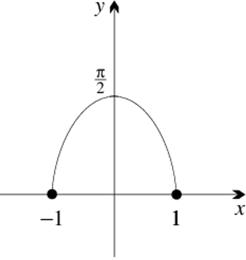
  - Sketch the graph of$y = f(x)$.

- Use chain-rule to differentiate:
- $tan^{-1}e^{3x}$  $$u = e^{3x},\frac{du}{dx}= 3e^{3x}$$  $$y=\tan^{-1}{u},\frac{dy}{du}=\frac{1}{1+u^{2}}$$  $$\frac{dy}{dx}=\frac{dy}{du}×\frac{du}{dx}=\frac{3e^{3x}}{1 + e^{6x}}$$ | - $sin⁻¹ x³$  $$u = x^{3},\frac{du}{dx}= 3x^{2}$$  $$y=\sin^{-1}{u},\frac{dy}{du}=\frac{1}{\sqrt{1-u^{2}}}$$  $$\frac{dy}{dx}=\frac{dy}{du}×\frac{du}{dx}=\frac{3x^{2}}{\sqrt{1 - x^{6}}}$$ | - $\cos^{-1}\left(log_{e}x\right)$  $$u = log_{e}x,\frac{du}{dx}=\frac{1}{x}$$  $$y=\cos^{-1}{u},\frac{dy}{du}=-\frac{1}{\sqrt{1-u^{2}}}$$  $$\frac{dy}{dx}=\frac{dy}{du}×\frac{du}{dx}=\frac{-\frac{1}{x}}{\sqrt{1 - {\left(\log_{e}x\right)}^{2}}}$$  $$= -\frac{1}{x\sqrt{1 - {\left(\log_{e}x\right)}^{2}}}$$

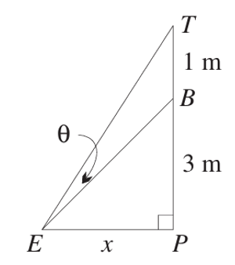
- A picture $TB$ that is 1 metre tall is hung on a wall
so that its bottom edge $B$ is 3 metres above the eye $E$ of a viewer.
Let the distance $EP$ be $x$ metres, and
let $θ$ be the angle that the picture subtends at $E$.

  - Show that $θ = tan^{-1}\left(\frac{4}{x}\right)- tan^{-1}\left(\frac{3}{x}\right)$.

From the diagram, angle to top of picture = $tan^{-1}\left(\frac{4}{x}\right)$ (opposite = 3 + 1 = 4), angle to bottom = $tan^{-1}\left(\frac{3}{x}\right).$
$$θ = tan^{-1}\left(\frac{4}{x}\right)- tan^{-1}\left(\frac{3}{x}\right)$$
  - Show that $θ$ is maximised when the viewer is $2\sqrt{3}$ metres from the wall.

$$\frac{dθ}{dx}= -\frac{4}{x^{2}+ 16}+\frac{3}{x^{2}+ 9}$$
$$Set\frac{dθ}{dx}= 0 and cross multiply$$
$$3\left(x^{2}+ 16\right)= 4\left(x^{2}+ 9\right)$$
$$3x^{2}+ 48 = 4x^{2}+ 36$$
$$x^{2}= 12$$
$$x = 2\sqrt{3}$$
  - Show that the maximum angle subtended by the picture at $E$ is $tan^{-1}\left(\frac{\sqrt{3}}{12}\right)$.

$$At x = 2\sqrt{3}: θ = tan^{-1}\left(\frac{4}{2\sqrt{3}}\right)- tan^{-1}\left(\frac{3}{2\sqrt{3}}\right)$$
$$= tan^{-1}\left(\frac{2}{\sqrt{3}}\right)- tan^{-1}\left(\frac{\sqrt{3}}{2}\right)$$
$$Take tan of both sides and use compound angle rule:$$
$$tan θ =\frac{\frac{2}{\sqrt{3}}-\frac{\sqrt{3}}{2}}{1 + \left(\frac{2}{\sqrt{3}}\right)\left(\frac{\sqrt{3}}{2}\right)}=\frac{\sqrt{3}}{12}$$
$$∴ θ = \tan^{-1}\left(\frac{\sqrt{3}}{12}\right)$$

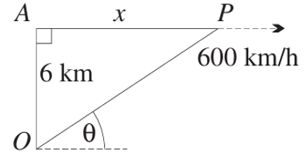
- A plane $P$ at a constant altitude of 6 km and at a constant speed of 600 km/h is flying directly away from an observer at $O$ on the ground.
The point $A$ on the path of the plane lies directly above $O$.
Let the distance $AP$ be $x$ km, and
let $θ$ be the angle of elevation of the plane from the observer.
  - Show that $θ = tan^{-1}\left(\frac{6}{x}\right).$

From the diagram, $tan θ =\frac{6}{x}, so θ = tan^{-1}\left(\frac{6}{x}\right)$
  - Show that $\frac{dθ}{dt}$ $=$ $-\frac{3600}{x^{2}+ 36}$ radians per hour.

$$\frac{dθ}{dx}=\frac{-\frac{6}{x^{2}}}{1 +\frac{36}{x^{2}}}= -\frac{6}{x^{2}+ 36}$$
$x = 600t$(km, $t$ in hours), so $\frac{dx}{dt}= 600$
$$\frac{dθ}{dt}=\frac{dθ}{dx}·\frac{dx}{dt}= -\frac{6}{x^{2}+ 36}· 600 = -\frac{3600}{x^{2}+ 36}$$
  - Hence find, in radians per second, the rate at which $θ$ is decreasing at the instant when the distance $AP$ is 3 km.

$$At x = 3:\frac{dθ}{dt}= -\frac{3600}{9 + 36}= -\frac{3600}{45}= -80 rad/hr$$
$$Convert: -\frac{80}{3600}= -\frac{1}{45} rad/s$$
$$Rate of decrease =\frac{1}{45} rad/s.$$

  - State the domain of $f(x) = tan⁻¹ x + \tan^{-1}\left(\frac{1}{x}\right),$ and its symmetry.
Domain: $x ≠ 0$ ($f$ is odd)
  - Show that $f'(x) = 0$ for all values of $x$ in the domain.
$f^{'}\left(x\right)=\frac{1}{1 + x^{2}}+\frac{-\frac{1}{x^{2}}}{1 +\frac{1}{x^{2}}}=\frac{1}{1 + x^{2}}-\frac{1}{x^{2}+ 1}= 0$
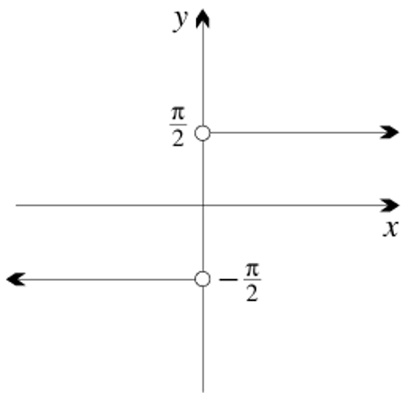
  - Show that $f(x) = \left\{\frac{π}{2}for x < 0, -\frac{π}{2}for x > 0\right\},$ and hence sketch the graph of $f(x).$
$f'(x) = 0$ means $f$ is constant on $x > 0$ and constant on $x < 0$ separately.
$$At x = 1: f\left(1\right)= tan^{-1}1 + tan^{-1}1 =\frac{π}{4}+\frac{π}{4}=\frac{π}{2}$$
$$f\left(x\right)=\frac{π}{2}for x > 0.$$
$$At x = -1: f\left(-1\right)= \tan^{-1}\left(-1\right)+ \tan^{-1}\left(-1\right)= -\frac{π}{4}-\frac{π}{4}= -\frac{π}{2},$$
$$f\left(x\right)= -\frac{π}{2}for x < 0.$$
$$∴ f(x) = \left\{\frac{π}{2}for x > 0, -\frac{π}{2}for x < 0\right\}$$

Integrating to Inverse Trigonometric Functions

- Integrating to Inverse Trig Functions
$$\int{\frac{1}{\sqrt{1-x^{2}}}}dx=\sin^{-1}{x}+C \\ \int{-\frac{1}{\sqrt{1-x^{2}}}}dx=\cos^{-1}{x}+C \\ \int{\frac{1}{1+x^{2}}}dx=\tan^{-1}{x}+C$$
- When evaluating definite integrals, remember range restrictions: (just use calculator)
$$-\frac{π}{2}≤\sin^{-1}{x}≤\frac{π}{2} 0≤\cos^{-1}{x}≤π -\frac{π}{2}≤\tan^{-1}{x}≤\frac{π}{2}$$

- Example Integrating to inverse trig functions
$$\int{\frac{2}{\sqrt{1-x^{2}}}}dx=2\int{\frac{1}{\sqrt{1-x^{2}}}}dx \\ =2\sin^{-1}{x}$$ | $$\int_{0}^{4}{\frac{1}{1+x^{2}}}dx={\left[ \tan^{-1}{x}\begin{matrix} \\ \\ \end{matrix}\right]}_{1}^{4} \\ =\tan^{-1}{4}-\tan^{-1}\left(1\right) \\ ≈0.54$$

- Guided Practice
$$\int{\frac{3}{\sqrt{1-x^{2}}}}dx$$  $$3\sin^{-1}\left(x\right)+C$$ | $$\int{\frac{1}{3+3x^{2}}}dx$$  $$\frac{1}{3}\tan^{-1}\left(x\right)+C$$
- Integrate this as $\sin^{-1}{}$ and $\cos^{-1}{}$ and show you get the same result.  $$\int_{0}^{\frac{1}{2}}{-\frac{1}{\sqrt{1-x^{2}}}}dx$$  $$-\frac{π}{6}$$ | $$\int_{0}^{1}{\frac{5}{1+x^{2}}}dx$$  $$\frac{5π}{4}$$
- Reverse Chain Rule for Integrating to Inverse Trig Functions
$$\int{\frac{f^{'}\left(x\right)}{\sqrt{1-{\left[f\left(x\right)\right]}^{2}}}}dx=\sin^{-1}{f\left(x\right)}+C \\ \int{\frac{f^{'}\left(x\right)}{1+{\left[f\left(x\right)\right]}^{2}}}dx=\tan^{-1}{f\left(x\right)}+C$$
- This is different to the standard integrals given on your reference sheet.
- Factor out the denominator to get 1. Rewrite denominator as ${\left[f\left(x\right)\right]}^{2}$.
- Identify $f\left(x\right)$ and $f^{'}\left(x\right)$.
- Adjust so the numerator is $f^{'}\left(x\right)$.
- Integrate.

- Example Reverse chain rule for inverse trig functions
$$\int{\frac{2}{\sqrt{9-x^{2}}}}dx$$  $$1. =\int{\frac{2}{3\sqrt{1-\frac{x^{2}}{9}}}}dx$$  $$=\int{\frac{2}{3\sqrt{1-{\left(\frac{x}{3}\right)}^{2}}}}dx$$  $2. f\left(x\right)$ is $\frac{x}{3}$. Need $\frac{1}{3}$ in the numerator.  $$3. =2\int{\frac{\left(\frac{1}{3}\right)}{\sqrt{1-{\left(\frac{x}{3}\right)}^{2}}}}dx$$  $$4. =2\sin^{-1}\left(\frac{x}{3}\right)+C$$ | $$\int{\frac{30x^{2}}{1+4x^{6}}}dx$$  $$1. =\int{\frac{30x^{2}}{1+{\left(2x^{3}\right)}^{2}}}dx$$  $2.$ $f\left(x\right)$ is $2x^{3}$. Need $6x^{2}$ in the numerator.  $$4. =5\int{\frac{6x^{2}}{1+{\left(2x^{3}\right)}^{2}}}dx$$  $$5. =5\tan^{-1}\left(2x^{3}\right)+C$$

- Guided Practice
$$\int{\frac{7}{\sqrt{16-x^{2}}}}dx$$  $$7\sin^{-1}\left(\frac{x}{4}\right)+C$$ | $$\int{\frac{1}{8+x^{2}}}dx$$  $$\frac{1}{2\sqrt{2}}\tan^{-1}\left(\frac{x}{2\sqrt{2}}\right)+C$$
- Guided Practice
$$\int{\frac{e^{x}}{1+e^{x}}}dx$$  $$\tan^{1}{e^{x}}+C$$ | $$\int{\frac{x}{\sqrt{1-x^{4}}}}dx$$  $$\frac{1}{2}\sin^{-1}\left(x^{2}\right)+C$$
$$\int{\frac{x^{2}}{\sqrt{1-4x^{6}}}}dx$$  $$\frac{1}{6}\sin^{-1}{(2x^{3})}+C$$ | $$\int{\frac{x^{2}}{1+4x^{6}}}dx$$  $$\frac{1}{12}\tan^{-1}\left(2x^{3}\right)+C$$
$$\int{\frac{5}{\sqrt{9-4x^{2}}}}dx$$  $$\frac{5}{2}\sin^{-1}\left(\frac{2x}{3}\right)+C$$ | $$\int{\frac{1}{5+2x^{2}}}dx$$  $$\frac{1}{\sqrt{10}}\tan^{-1}\left(\frac{\sqrt{2}x}{\sqrt{5}}\right)+C$$

Foundation
- Find:
- $\int{\frac{-1}{\sqrt{1-x^{2}}}}dx$  $$\cos^{-1}x + C$$ | - $\int{\frac{1}{\sqrt{4-x^{2}}}}dx$  $$\sin^{-1}\left(\frac{x}{2}\right)+ C$$ | - $\int{\frac{1}{9+x^{2}}}dx$  $$\frac{1}{3}\tan^{-1}\left(\frac{x}{3}\right)+ C$$
- $\int{\frac{1}{\sqrt{\frac{4}{9}-x^{2}}}}dx$  $$\sin^{-1}\left(\frac{3x}{2}\right)+ C$$ | - $\int{\frac{1}{2+x^{2}}}dx$  $$\frac{1}{\sqrt{2}}\tan^{-1}\left(\frac{x}{\sqrt{2}}\right)+ C$$ | - $\int{\frac{-1}{\sqrt{5-x^{2}}}}dx$  $$\cos^{-1}\left(\frac{x}{\sqrt{5}}\right)+ C$$

- Find the exact value of:
- $\int_{0}^{3}{\frac{1}{\sqrt{9-x^{2}}}}dx$  $$\frac{π}{2}$$ | - $\int_{0}^{2}{\frac{1}{4+x^{2}}}dx$  $$\frac{π}{8}$$ | - $\int_{0}^{1}{\frac{1}{\sqrt{2-x^{2}}}}dx$  $$\frac{π}{4}$$
- $\int_{\frac{1}{2}}^{\frac{\sqrt{3}}{2}}{\frac{\frac{1}{2}}{\frac{1}{4}+x^{2}}}dx$  $$\frac{π}{12}$$ | - $\int_{\frac{\sqrt{3}}{6}}^{\frac{1}{6}}{\frac{-1}{\sqrt{\frac{1}{9}-x^{2}}}}dx$  $$\frac{π}{6}$$ | - $\int_{-\frac{3\sqrt{2}}{4}}^{\frac{3}{4}}{\frac{1}{\sqrt{\frac{9}{4}-x^{2}}}}dx$  $$\frac{5π}{12}$$

- Find the equation of the curve, given that:
  - $y^{'}= {\left(1-x^{2}\right)}^{-\frac{1}{2}}$ and the curve passes through $(0, π)$

$$y = \int{{\left(1-x^{2}\right)}^{-\frac{1}{2}}dx}= sin^{-1}x + C$$
$$Sub \left(0, π\right): π = sin^{-1}\left(0\right)+ C = C$$
$$∴ y = sin^{-1}x + π$$
  - $y' = 4{\left(16+x^{2}\right)}^{-1}$ and the curve passes through $(-4, 0)$

$$y = \int{\frac{4}{16+x^{2}}}dx = 4·\left(\frac{1}{4}\right)tan^{-1}\left(\frac{x}{4}\right)+ C = tan^{-1}\left(\frac{x}{4}\right)+ C$$
$$Sub \left(-4, 0\right): 0 = tan^{-1}\left(-1\right)+ C = -\frac{π}{4}+ C, so C =\frac{π}{4}$$
$$∴ y = tan^{-1}\left(\frac{x}{4}\right)+\frac{π}{4}$$

  - If $y^{'}=\frac{1}{\sqrt{36-x^{2}}}$ and $y =\frac{π}{6}$ when $x = 3$, find $y$ when $x = 3\sqrt{3}$.
$$y = \int{\frac{1}{\sqrt{36-x^{2}}}}dx = sin^{-1}\left(\frac{x}{6}\right)+ C$$
$$Sub x = 3, y =\frac{π}{6}:\frac{π}{6}= sin^{-1}\left(\frac{1}{2}\right)+ C =\frac{π}{6}+ C, so C = 0$$
$$∴ y = sin^{-1}\left(\frac{x}{6}\right)$$
$$At x = 3\sqrt{3}: y = sin^{-1}\left(\frac{3\sqrt{3}}{6}\right)= sin^{-1}\left(\frac{\sqrt{3}}{2}\right)=\frac{π}{3}$$
  - Given that $y^{'}=\frac{2}{4+x^{2}}$ and $y =\frac{π}{3}$ when $x = 2$, find $y$ when $x =\frac{2}{\sqrt{3}}$.

$$y = \int{\frac{2}{4+x^{2}}}dx = 2·\left(\frac{1}{2}\right)tan^{-1}\left(\frac{x}{2}\right)+ C = tan^{-1}\left(\frac{x}{2}\right)+ C$$
$$Sub x = 2, y =\frac{π}{3}:\frac{π}{3}= tan^{-1}\left(1\right)+ C =\frac{π}{4}+ C, so C =\frac{π}{12}$$
$$∴ y = tan^{-1}\left(\frac{x}{2}\right)+\frac{π}{12}$$
$$At x =\frac{2}{\sqrt{3}}: y = tan^{-1}\left(\frac{1}{\sqrt{3}}\right)+\frac{π}{12}=\frac{π}{6}+\frac{π}{12}=\frac{π}{4}$$

- Find:
- $\int{\frac{1}{\sqrt{1-4x^{2}}}}dx$  $$\frac{1}{2}\sin^{-1}\left(2x\right)+ C$$ | - $\int{\frac{1}{1+16x^{2}}}dx$  $$\frac{1}{4}\tan^{-1}\left(4x\right)+ C$$ | - $\int{\frac{-1}{\sqrt{1-2x^{2}}}}dx$  $$\frac{1}{\sqrt{2}}\cos^{-1}\left(\sqrt{2}x\right)+ C$$
- $\int{\frac{1}{\sqrt{4-9x^{2}}}}dx$  $$\frac{1}{3}\sin^{-1}\left(\frac{3x}{2}\right)+ C$$ | - $\int{\frac{1}{25+9x^{2}}}dx$  $$\frac{1}{15}\tan^{-1}\left(\frac{3x}{5}\right)+ C$$ | - $\int{\frac{-1}{\sqrt{3-4x^{2}}}}dx$  $$\frac{1}{2}\cos^{-1}\left(\frac{2x}{\sqrt{3}}\right)+ C$$

- Find the exact value of:
- $\int_{0}^{\frac{1}{6}}{\frac{1}{\sqrt{1-9x^{2}}}}dx$  $$\frac{π}{18}$$ | - $\int_{\frac{1}{2}}^{\frac{\sqrt{3}}{2}}{\frac{2}{1+4x^{2}}}dx$  $$\frac{π}{12}$$ | - $\int_{-\frac{1}{2}}^{\frac{1}{2}}{\frac{1}{\sqrt{1-3x^{2}}}}dx$  $$\frac{2π\sqrt{3}}{9}$$

Development

  - Shade the region bounded by $y = sin⁻¹x$, the $x$-axis and the vertical line $x =\frac{1}{2}$.
  - Show that $\frac{d}{dx}\left(x sin^{-1}x + \sqrt{1-x^{2}}\right) = sin⁻¹x$.
  - Hence find the exact area of the region.
$$\frac{d}{dx}\left(x \sin^{-1}x + \sqrt{1-x^{2}}\right)= \sin^{-1}x +\frac{x}{\sqrt{1-x^{2}}}+\frac{-2x}{2\sqrt{1-x^{2}}}$$
$$= \sin^{-1}x +\frac{x}{\sqrt{1-x^{2}}}-\frac{x}{\sqrt{1-x^{2}}}$$
$$= \sin^{-1}x$$

$$Area = \int_{0}^{\frac{1}{2}}{sin^{-1}x}dx = {\left[x sin^{-1}x + \sqrt{1-x^{2}}\right]}_{0}^{\frac{1}{2}}$$
$$= \left(\left(\frac{1}{2}\right)sin^{-1}\left(\frac{1}{2}\right)+ \sqrt{\frac{3}{4}}\right)- \left(0 + 1\right)$$
$$=\frac{π}{12}+\frac{\sqrt{3}}{2}- 1 unit^{2}$$

  - Shade the region bounded by $y = sin⁻¹x$, the $y$-axis and the line $y =\frac{π}{6}$.
  - Find the exact area of this region.
  - Hence confirm the area in the previous question.
Region bounded by $y = sin⁻¹x$, $y$-axis, $y =\frac{π}{6}$. Integrating with respect to $y$: $x = sin y$.
$$Area = \int_{0}^{\frac{π}{6}}{sin}y dy = {\left[-cos y\right]}_{0}^{\frac{π}{6}}$$
$$= -cos\left(\frac{π}{6}\right)+ cos\left(0\right)$$
$$= 1 -\frac{\sqrt{3}}{2} {unit}^{2}$$

$$The two regions together form the rectangle with vertices \left(0,0\right), \left(\frac{1}{2,0}\right), \left(\frac{1}{2},\frac{π}{6}\right), \left(0,\frac{π}{6}\right)$$
$$area = \left(\frac{1}{2}\right)\left(\frac{π}{6}\right)=\frac{π}{12}.$$
$$so \left(\frac{π}{12}+\frac{\sqrt{3}}{2}- 1\right) +\left(1 -\frac{\sqrt{3}}{2}\right)$$
$$=\frac{π}{12} as expected.$$

  - Show that $\frac{d}{dx}\left(cos^{-1}\left(2-x\right)\right)=\frac{1}{\sqrt{4x-x^{2}-3}}$.
  - Hence find $\int_{1}^{2}{\frac{1}{\sqrt{4x-x^{2}-3}}}dx$.
$$\frac{d}{dx}\left(cos^{-1}\left(2-x\right)\right)= -\frac{1}{\sqrt{1-{\left(2-x\right)}^{2}}}· \left(-1\right)$$
$$=\frac{1}{\sqrt{1-\left(4-4x+x^{2}\right)}}=\frac{1}{\sqrt{4x-x^{2}-3}}$$
$$\int_{1}^{2}{\frac{1}{\sqrt{4x-x^{2}-3}}}dx = {\left[cos^{-1}\left(2-x\right)\right]}_{1}^{2}$$
$$= cos^{-1}\left(0\right)- cos^{-1}\left(1\right)$$
$$=\frac{π}{2}- 0 =\frac{π}{2}$$

  - Differentiate $\tan^{-1}\left(\frac{x^{3}}{2}\right).$
  - Hence find $\int{\frac{x^{2}}{4+x^{6}}}dx$.

$$\frac{d}{dx}\left(\tan^{-1}\left(\frac{x^{3}}{2}\right)\right)= \left(\frac{1}{1+{\left(\frac{x^{3}}{2}\right)}^{2}}\right)·\frac{3}{2}x^{2}=\frac{\frac{3x^{2}}{2}}{1 +\frac{x^{6}}{4}}=\frac{6x^{2}}{4+x^{6}}$$
$$since \int{\frac{6x^{2}}{4+x^{6}}}dx = \tan^{-1}\left(\frac{x^{3}}{2}\right)+ C$$
$$∴ \int{\frac{x^{2}}{4+x^{6}}}dx =\frac{1}{6}\tan^{-1}\left(\frac{x^{3}}{2}\right)+ C$$

  - Differentiate $x tan⁻¹x$.
  - Hence find $\int_{0}^{1}{tan^{-1}x}dx$.
$$\frac{d}{dx}\left(x \tan^{-1}x\right)= \tan^{-1}x +\frac{x}{1+x^{2}}$$
$$since \int{\left(\tan^{-1}x +\frac{x}{1+x^{2}}\right)dx}= x \tan^{-1}x + C$$
$$∴ \int{\tan^{-1}x}dx = x \tan^{-1}x - \int{\frac{x}{1+x^{2}}}dx$$
$$\int_{0}^{1}{\tan^{-1}x}dx = {\left[x \tan^{-1}x -\frac{1}{2}ln\left(1+x^{2}\right)\right]}_{0}^{1}$$
$$= \left(1·\frac{π}{4}-\frac{1}{2}ln 2\right)- 0$$
$$=\frac{π}{4}-\frac{1}{2}ln 2$$

- Without finding any primitives, use arguments from symmetry or geometry to evaluate:
- $\int_{-\frac{1}{3}}^{\frac{1}{3}}{\sin^{-1}x}dx$  sin⁻¹x is an odd function, limits are symmetric about 0. ∴ = 0 | - $\int_{-5}^{5}{\tan^{-1}x}dx$  tan⁻¹x is an odd function, limits symmetric about 0. ∴ = 0 | - $\int_{-\frac{3}{4}}^{\frac{3}{4}}{\cos^{-1}x}dx$  cos⁻¹x is neither odd nor even.  The graph has odd symmetry about $y=\frac{π}{2}$  the area "above" the line $y =\frac{π}{2}$ (on the left side) is exactly equal to the area below that line (on the right side).  So we can model the area as a rectangle.  $$∴ \int_{-\frac{3}{4}}^{\frac{3}{4}}{cos^{-1}x}dx =\frac{π}{2}·\frac{3}{2}=\frac{3π}{4}.$$
- $\int_{-\frac{2}{3}}^{\frac{2}{3}}{\frac{x}{\sqrt{1-x^{2}}}}dx$  $\frac{x}{\sqrt{1-x^{2}}}$ is an odd function, limits symmetric about 0. ∴ = 0 | - $\int_{-3}^{3}{\frac{x}{1+x^{2}}}dx$  $\frac{x}{1+x^{2}}$ is an odd function, limits symmetric about 0. ∴ = 0 | - $\int_{-6}^{6}{\sqrt{36-x^{2}}}dx$  $\sqrt{36-x^{2}}≥ 0$ on [−6, 6]  describes the upper semicircle of radius 6.  $$Area =\frac{1}{2}π\left(6^{2}\right)= 18π$$

Mastery
- Given that $f\left(x\right)=\frac{x}{1+x^{2}}- tan^{-1}x$:
  - find $f(0)$
  - show that $f^{'}\left(x\right)=\frac{-2x^{2}}{{\left(1+x^{2}\right)}^{2}}$
  - Hence explain why $f(x) < 0$ for all $x > 0$
  - Hence find $\int_{0}^{1}{\frac{x^{2}}{{\left(1+x^{2}\right)}^{2}dx}}$

$$f\left(0\right)=\frac{0}{1+0}- \tan^{-1}\left(0\right)= 0$$
$$f^{'}\left(x\right)=\frac{d}{dx}\left(\frac{x}{1+x^{2}}\right)-\frac{1}{1+x^{2}}$$
$$\frac{d}{dx}\left(\frac{x}{1+x^{2}}\right)=\frac{\left(1+x^{2}\right)- x·2x}{{\left(1+x^{2}\right)}^{2}}=\frac{1-x^{2}}{{\left(1+x^{2}\right)}^{2}}$$
$$f^{'}\left(x\right)=\frac{1-x^{2}}{{\left(1+x^{2}\right)}^{2}}-\frac{1}{1+x^{2}}=\frac{1-x^{2}}{{\left(1+x^{2}\right)}^{2}}-\frac{1+x^{2}}{{\left(1+x^{2}\right)}^{2}}= -\frac{2x^{2}}{{\left(1+x^{2}\right)}^{2}}$$
$$f\left(0\right)= 0 and f^{'}\left(x\right)= -\frac{2x^{2}}{{\left(1+x^{2}\right)}^{2}}≤ 0 for all x, with equality only at x = 0.$$
$$So f is non-increasing and starts at 0, ∴ f\left(x\right)< 0 for x > 0.$$
$$f\left(x\right)=\frac{x}{1+x^{2}}- \tan^{-1}x, so:$$
$$\int_{0}^{1}{\frac{-2x^{2}}{{\left(1+x^{2}\right)}^{2}dx}}= {\left[\frac{x}{1+x^{2}}- \tan^{-1}x\right]}_{0}^{1}= \left(\frac{1}{2}-\frac{π}{4}\right)- 0$$
$$∴ \int_{0}^{1}{\frac{x^{2}}{{\left(1+x^{2}\right)}^{2}dx}}= \left(\frac{1}{2}\right)\left(\frac{π}{4}-\frac{1}{2}\right)=\frac{π}{8}-\frac{1}{4}$$
- Consider the function $f\left(x\right)=\frac{1}{\sqrt{4-x^{2}}}.$
  - Sketch the graph of $y = \sqrt{4-x^{2}}.$
  - Hence sketch the graph of $y = f(x)$.
  - Write down the domain and range of $f(x),$ and describe its symmetry.
  - Find the area between the curve and the $x$-axis from $x = -1$to $x = 1.$
  - Find the total area between the curve and the x-axis.
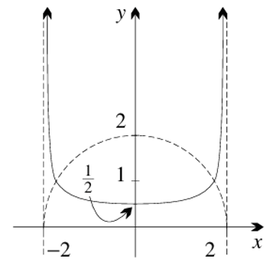
$$Domain: -2 < x < 2 \left(i.e. x ≠ ±2\right), range: y ≥\frac{1}{2}, even function.$$

$$\int_{-1}^{1}{\frac{1}{\sqrt{4-x^{2}}}dx} = \left[\sin^{-1}\left(\frac{x}{2}\right)\right]{\left(-1\right)}^{1}= \sin^{-1}\left(\frac{1}{2}\right)- \sin^{-1}\left(-\frac{1}{2}\right)$$
$$=\frac{π}{6}- \left(-\frac{π}{6}\right)=\frac{π}{3}{unit}^{2}$$

$$The total area = \int_{-2}^{2}{\frac{1}{\sqrt{4-x^{2}}}dx} = {\left[\sin^{-1}\left(\frac{x}{2}\right)\right]}_{-2}^{2}$$
$$=\frac{π}{2}- \left(-\frac{π}{2}\right)= π {unit}^{2}$$

- Consider the function $f\left(x\right)=\frac{4}{x^{2}+4}$.
  - What is the axis of symmetry of $y = f(x)?$
  - What are the domain and range?
  - Show that the graph of $f(x)$ has a maximum turning point at $(0, 1)$.
  - Find $lim_{x→∞} f(x)$, and hence sketch $y = f(x)$.
On the same axes, sketch $y =\frac{x^{2}+4}{4}$.
  - Calculate the area bounded by the curve and the $x$-axis from $x = -2\sqrt{3}$ to $x = \frac{2\sqrt{3}}{3}$.
  - Find the exact area between the curve and the $x$-axis from $x = -a$ to $x = a$, where $a$ is a positive constant.
  - By letting a tend to infinity, find the total area between the curve and the $x$-axis.
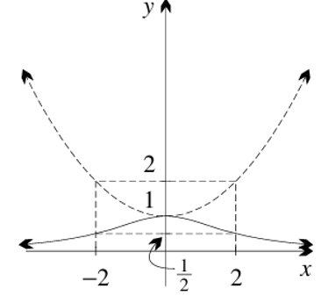
$$y axis, since f(x) is an even function.$$

$$Domain: all real x; range: 0 < y ≤ 1.$$

$$f^{'}\left(x\right)= -\frac{8x}{{\left(x^{2}+4\right)}^{2}}. f^{'}\left(0\right)= 0.$$
$$f^{''}\left(x\right) at x = 0: f^{''}\left(0\right)= -\frac{8}{4^{2}}· \left(check sign\right)< 0. ∴ maximum at \left(0, f\left(0\right)\right)= \left(0, 1\right).$$

$$\lim_{x→∞}f\left(x\right)= 0, so y = 0 is a horizontal asymptote.$$

$$\int_{-2\sqrt{3}}^{\frac{2\sqrt{3}}{3}}{\frac{4}{x^{2}+4}}dx = {\left[4·\left(\frac{1}{2}\right)\tan^{-1}\left(\frac{x}{2}\right)\right]}_{-2\sqrt{3}}^{\frac{2\sqrt{3}}{3}}= {\left[2\tan^{-1}\left(\frac{x}{2}\right)\right]}_{-2\sqrt{3}}^{\frac{2\sqrt{3}}{3}}$$
$$= 2\tan^{-1}\left(\frac{\sqrt{3}}{3}\right)- 2\tan^{-1}\left(-\sqrt{3}\right)= 2\left(\frac{π}{6}\right)- 2\left(-\frac{π}{3}\right)=\frac{π}{3}+\frac{2π}{3}= π {unit}^{2}$$

$$\int_{-a}^{a}{\frac{4}{x^{2}+4}}dx = \left[2\tan^{-1}\left(\frac{x}{2}\right)\right]{\left(-a\right)}^{a}= 2\tan^{-1}\left(\frac{a}{2}\right)- 2\tan^{-1}\left(-\frac{a}{2}\right)= 4\tan^{-1}\left(\frac{a}{2}\right){unit}^{2}$$

$$As a → ∞: \tan^{-1}\left(\frac{a}{2}\right)→\frac{π}{2}, so total area = 4·\left(\frac{π}{2}\right)= 2π {unit}^{2}$$

  - Use the trapezoidal rule with five points to approximate $I = \int_{0}^{1}{\frac{1}{1+x^{2}}}dx$, expressing your answer in simplest fraction form.
  - Find the exact value of $I$, and hence show that $π ≈\frac{5323}{1700}$.
$$Five points at x = 0,\frac{1}{4},\frac{1}{2},\frac{3}{4}, 1. h =\frac{1}{4}.$$
$$f\left(0\right)= 1, f\left(\frac{1}{4}\right)=\frac{16}{17}, f\left(\frac{1}{2}\right)=\frac{4}{5}, f\left(\frac{3}{4}\right)=\frac{16}{25}, f\left(1\right)=\frac{1}{2}.$$
$$Trapezoidal rule: \left(\frac{1}{4}\right)·\left(\frac{1}{2}\right)\left(f\left(0\right)+ 2f\left(\frac{1}{4}\right)+ 2f\left(\frac{1}{2}\right)+ 2f\left(\frac{3}{4}\right)+ f\left(1\right)\right)$$
$$= \left(\frac{1}{8}\right)\left(1 +\frac{32}{17}+\frac{8}{5}+\frac{32}{25}+\frac{1}{2}\right)$$
$$=\frac{5323}{6800}$$

$$\int_{0}^{1}{\frac{1}{1+x^{2}}}dx = {\left[\tan^{-1}x\right]}_{0}^{1}=\frac{π}{4}- 0 =\frac{π}{4}$$
$$∴\frac{π}{4}≈\frac{5323}{6800}⟹ π ≈ 4·\left(\frac{5323}{6800}\right)=\frac{5323}{1700}$$

- Show that $\int_{-\frac{1}{4}}^{\frac{3}{5}}{\frac{1}{1+x^{2}}}dx =\frac{π}{4}$.

$$\int_{-\frac{1}{4}}^{\frac{3}{5}}{\frac{1}{1+x^{2}}}dx = {\left[\tan^{-1}x\right]}_{-\frac{1}{4}}^{\frac{3}{5}}$$
$$Need \tan^{-1}\left(\frac{3}{5}\right)- \tan^{-1}\left(-\frac{1}{4}\right)= \tan^{-1}\left(\frac{3}{5}\right)+ \tan^{-1}\left(\frac{1}{4}\right).$$
$$Using tan\left(A+B\right)=\frac{tan A + tan B}{1 - tan A tan B}:$$
$$tan\left(\tan^{-1}\left(\frac{3}{5}\right)+ \tan^{-1}\left(\frac{1}{4}\right)\right)=\frac{\frac{3}{5}+\frac{1}{4}}{1 -\frac{3}{20}}=\frac{\frac{17}{20}}{\frac{17}{20}}= 1$$
$$∴ \tan^{-1}\left(\frac{3}{5}\right)+ \tan^{-1}\left(\frac{1}{4}\right)=\frac{π}{4}$$
- Find, using the substitution:
  - $\int{\frac{1}{\sqrt{x\left(1+x\right)}}}dx using u=\sqrt{x}$
  - $\int_{0}^{1}{\frac{1}{e^{-x}+eˣ}}dx using u=e^{x}$
$$Let u = \sqrt{x}, so x = u^{2}, dx = 2u du.$$
$$\int{\frac{1}{\sqrt{x\left(1+x\right)}}}dx = \int{\frac{1}{u\left(1+u^{2}\right)}}· 2u du = \int{\frac{2}{1+u^{2}}}du = 2\tan^{-1}u + C = 2\tan^{-1}\sqrt{x}+ C$$

$$\int_{0}^{1}{\frac{1}{e^{-x}+eˣ}}dx = \int_{0}^{1}{\frac{eˣ}{1+e^{2x}}}dx$$
$$Let u = eˣ, du = eˣ dx.$$
$$= \int_{1}^{e}{\frac{1}{1+u^{2}}}du = {\left[\tan^{-1}u\right]}_{1}^{e}= \tan^{-1}e -\frac{π}{4}$$

Integration by Substitution

- Investigation Integration by Substitution
Integrate using reverse chain rule:
$$\int{\cos{(3x+1})}dx$$

Now try
$$\int{\frac{\cos{\sqrt{x}}}{\sqrt{x}}}dx$$

When you cannot easily recognise reverse chain rule, we can use a substitution:
$$\int{\frac{\cos{\sqrt{x}}}{\sqrt{x}}}dx using the subsitution u=\sqrt{x}$$
1. Replace all instances of $\sqrt{x}$ with $u$.

2. Rewrite $dx$ using $du$ by finding $\frac{du}{dx}$ and rearranging:

3. Integrate:

4. Back substitute:

- Integration by Substitution
The reverse chain rule can be difficult to apply when expressions become complex. Integration by substitution is a method that simplifies the integral by replacing part of the expression with a new variable, $u$.
Set out your working out like this: Substitution steps on the right, main working on the left.
- Replace every $x$ expression with $u$, and replace $dx$with the expression from step 3.  - Integrate with respect to $u$.  - Back-substitute: replace all instances of $u$ with the expression in $x$. | - Let $u=u\left(x\right)$  - Find $\frac{du}{dx}$  - Rearrange to get $dx$ in terms of $du$.
- If a question asks you to integrate using a substitution, you must do so, showing all steps.

- Example Integration by substitution
$$\int{x{\left(1-x^{2}\right)}^{4}}dx using u=1-x^{2}$$
$$4. \int{x{\left(1-x^{2}\right)}^{4}}dx=\int{x\left(u^{4}\right)\frac{du}{-2x}}$$  $$=\int{\frac{u^{4}}{-2}} du$$  $$5. =-\frac{u^{5}}{10}+C$$  $$6. =-\frac{{\left(1-x^{2}\right)}^{5}}{10}+C$$ | $1.$ Let $u=1-x^{2}$  $$2. \frac{du}{dx}=-2x$$  $$3. du= -2x dx$$  $$dx=\frac{du}{-2x}$$

- Guided Practice
$$\int{\sin{x}\sqrt{1-\cos{x}}dx} using u=1-\cos{x}$$
 | $$\frac{2}{3}\sqrt{{\left(1-\cos{x}\right)}^{3}}+C$$
$$\int{x\sqrt{x+1}}dx using u=x+1$$
 | $$\frac{2}{5}\sqrt{{\left(x+1\right)}^{5}}-\frac{2}{3}\sqrt{{\left(x+1\right)}^{3}}+C$$
- Integrating Definite Integrals by Substitution
When integrating definite integrals by substitution, you must change the limits.
You do not need to back-substitute.
- Replace every $x$ expression with $u$, and $dx$with the expression from step 3. Replace the limits.  - Integrate with respect to $u$. | - Let $u=u\left(x\right)$  - Find $\frac{du}{dx}$  - Rearrange to get $dx$ in terms of $du$.  - Change the limits to $u$.

- Example Integrate definite integrals by substitution
$$\int_{0}^{1}{x\sqrt{1-x}}dx using u=1-x$$
$$5. \int_{0}^{1}{x\sqrt{1-x}}dx=\int_{1}^{0}{\left(1-u\right)\sqrt{u}}\left(-du\right)$$  $$=-\int_{1}^{0}{\sqrt{u}-u\sqrt{u}}du$$  $$6. =-{\left[\frac{2}{3}u^{\frac{3}{2}}-\frac{2}{5}u^{\frac{5}{2}}\right]}_{1}^{0}$$  $$=-\left(\left(0-0\right)-\left(\frac{2}{3}-\frac{2}{5}\right)\right)$$  $$=\frac{4}{15}$$ | $1.$ Let $u=1-x$ , so $x=1-u$  $$2. \frac{du}{dx}=-1$$  $$3. dx=-du$$  $$4. when x=0, u=1-0=1$$  $$when x=1, u=1-1=0$$

- Guided Practice
$$\int_{0}^{2}{x^{2}\sqrt{x^{3}+1}}dx using u=x^{3}+1$$
$$\frac{52}{9}$$
$$\int_{0}^{π}{\cos^{6}{x}\sin{x}}dx using u=\cos{x}$$
$$\frac{2}{7}$$
- Investigation Integration by Substitution: Geometric representation.
Let’s see what integration by substitution does geometrically. Consider: $u=3x+1$
$$\int_{0}^{\frac{2π}{3}}{\cos{(3x+1)}}dx↦\frac{1}{3}\int_{1}^{2π+1}{\cos{u}du}$$
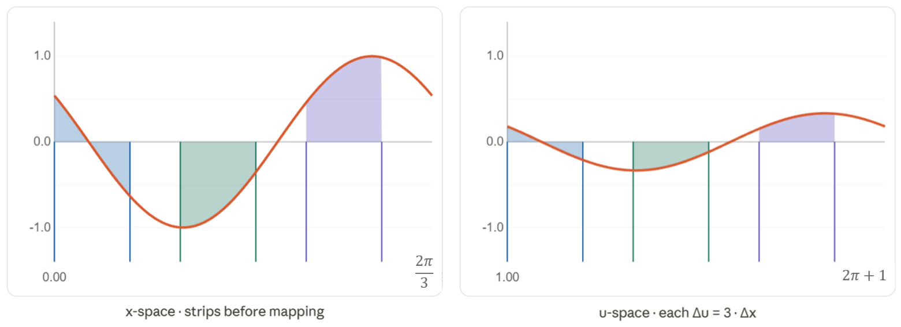

The substitution maps the graph of $\cos{(3x+1)}$ to $\frac{1}{3}\cos{u}$.
The new graph is a simpler cosine, but it is one-third the height and three times the width.
To preserve the area under the curve, each strip of width $Δx$ in the original must become three times as wide in the $u$-space which is what $du=3 dx$ accounts for.
This works neatly here because $u=3x+1$is a linear transformation. Consider $u=\sqrt{x}$:
$$\int_{0}^{4π^{2}}{\frac{\cos{\sqrt{x}}}{\sqrt{x}}}dx↦\int_{0}^{2π}{\cos{u}du}$$
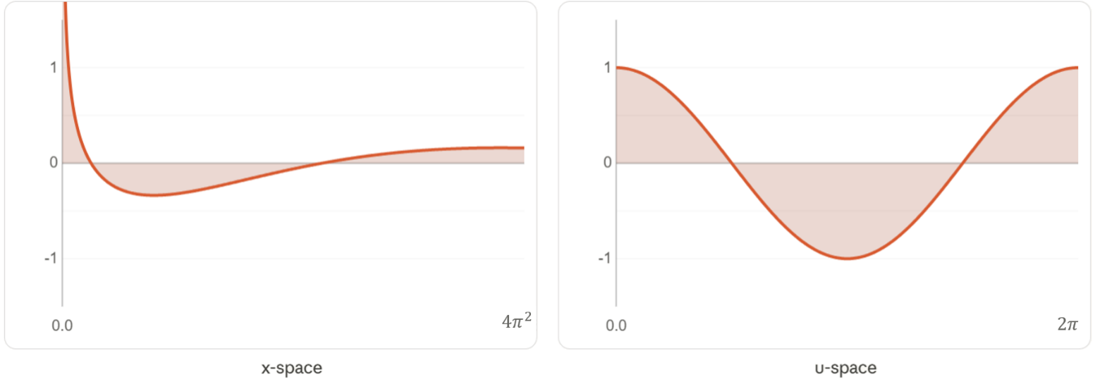

Here, the substitution distorts the $x$-axis non-uniformly to produce the simpler cosine graph on the right. Because this a non-linear transformation, the width $Δx$ changes depending on where you are on the $x$-axis:
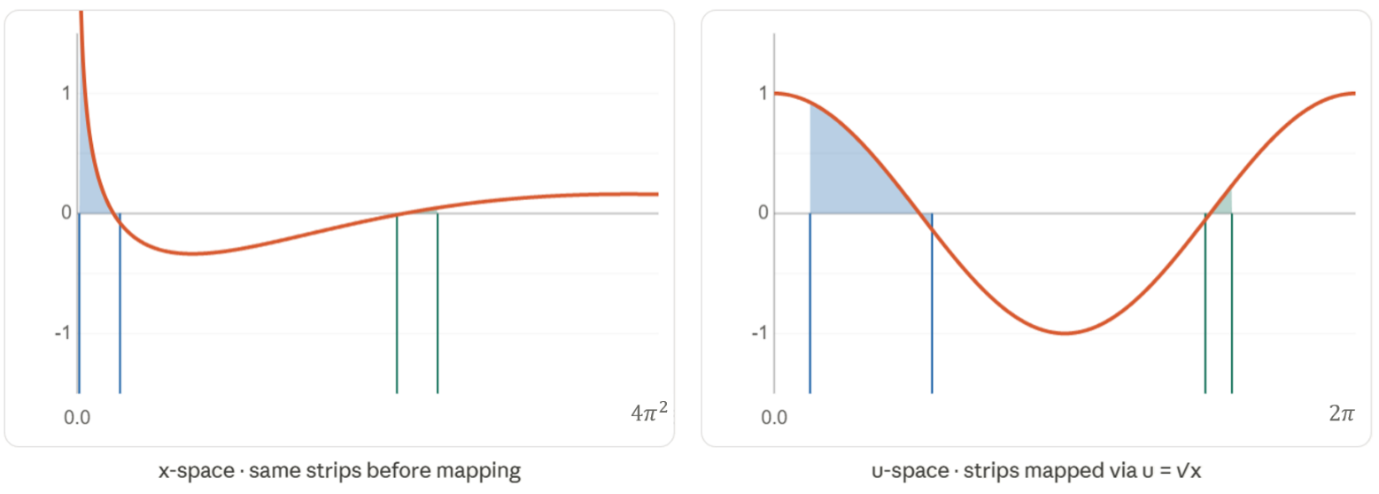

Two strips of equal width $Δx$ are shown on the left graph. To map to an equal area in the $u$-space, the strip near $x=0$ is tall and thin; the one further right is shorter and wider.
The substitution compresses and stretches different parts of the $x$-axis by different amounts.
This is what $du=\frac{1}{2\sqrt{x}} dx$ accounts for.

Foundation
- Consider $\int{ 2x{\left(1 + x^{2}\right)}^{3} dx}$, with $u = 1 + x².$
  - Show that $du = 2x dx$.
  - Show the integral can be written as $\int{ u^{3}du}$.
  - Hence find the primitive of $2x{\left(1 + x^{2}\right)}^{3}.$
  - Check by differentiating.

$$a) u = 1 + x^{2}$$
$$\frac{du}{dx}= 2x$$
$$du = 2x dx$$
$$b) \int{ 2x{\left(1 + x^{2}\right)}^{3}dx}= \int{ u^{3}du}$$
$$c) \int{ u^{3}du}=\frac{u^{4}}{4}+ C = \left(\frac{1}{4}\right){\left(1 + x^{2}\right)}^{4}+ C$$
$d)\frac{d}{dx}\left(\left(\frac{1}{4}\right){\left(1 + x^{2}\right)}^{4}\right)= \left(\frac{1}{4}\right)\left(4\right){\left(1 + x^{2}\right)}^{3}\left(2x\right)= 2x{\left(1 + x^{2}\right)}^{3}$
- Find each indefinite integral using the given substitution.
- $\int{2{\left(2x+3\right)}^{3} dx}, u=2x+3$  $$=\frac{1}{4}{\left(2x+3\right)}^{4}+C$$ | - $\int{3x^{2}{\left(1+x^{3}\right)}^{4} dx}, u=1+x^{3}$  $$=\frac{1}{5}{\left(1+x^{3}\right)}^{5}+C$$
- $\int{\frac{2x}{{\left(1+x^{2}\right)}^{2}}dx}, u=1+x^{2}$  $$=\frac{-1}{1+x^{2}}+C$$ | - $\int{\frac{3}{\sqrt{3x-5}}dx}, u=3x-5$  $$=2\sqrt{3x-5}+C$$
- $\int{\sin^{3}xcosx dx}, u=sinx$  $$=\frac{1}{4}sin^{4}x+C$$ | - $\int{\frac{4x^{3}}{1+x^{4}}dx}, u=1+x^{4}$  $$=ln\left(1+x^{4}\right)+C$$
- Consider $\int{\frac{x}{\sqrt{1 - x^{2}}}dx}$, with $u = 1 - x².$
  - Show that $x dx = -\frac{1}{2}du.$
  - Show the integral can be written as $-\frac{1}{2}\int{ u^{-\frac{1}{2}}du}$.
  - Hence find the primitive of $\frac{x}{\sqrt{1 - x^{2}}}.$
$$a) u = 1 - x^{2}$$
$$du = -2x dx$$
$$x dx = -\frac{1}{2}du$$
$$b) \int{\frac{x}{\sqrt{1 - x^{2}}}dx}= \int{ \left(\frac{1}{\sqrt{u}}\right)\left(-\frac{1}{2}\right)du}$$
$$= -\frac{1}{2}\int{ u^{-\frac{1}{2}}du}$$
$$c) -\frac{1}{2}\left(2\sqrt{u}\right)+ C = -\sqrt{u}+ C$$
$$= -\sqrt{1 - x^{2}}+ C$$
- Find each indefinite integral using the given substitution.
- $\int{x^{3}{\left(x^{4}+1\right)}^{5} dx}, u=x^{4}+1$  $$\frac{1}{24}{\left(x^{4}+1\right)}^{6}+C$$ | - $\int{x^{2}\sqrt{x^{3}-1} dx}, u=x^{3}-1$  $$\frac{2}{9}{\left(x^{3}-1\right)}^{\frac{3}{2}}+C$$
- $\int{x^{2}e^{x^{3}}dx}, u=x^{3}$  $$\frac{1}{3}e^{x^{3}}+C$$ | - $\int{\frac{1}{\sqrt{x{\left(1+\sqrt{x}\right)}^{3}}}dx}, u=1+\sqrt{x}$  $$\frac{-1}{{\left(1+\sqrt{x}\right)}^{2}}+C$$
- $\int{tan^{2}2xsec^{2}2x dx}, u=tan2x$  $$\frac{1}{6}\tan^{3}2x+C$$ | - $\int{\frac{e^{\frac{1}{x}}}{x^{2}}dx}, u=\frac{1}{x}$  $$-e^{\frac{1}{x}}+C$$

Development
- Find the exact value of each definite integral using the given substitution.
- $\int_{0}^{1}{x^{2}{\left(2+x^{3}\right)}^{3} dx}, u=2+x^{3}$  $$\frac{65}{12}$$ | - $\int_{0}^{1}{\frac{2x^{3}}{\sqrt{1+x^{4}}} dx}, u=1+x^{4}$  $$\sqrt{2}-1$$
- $\int_{0}^{\frac{π}{2}}{cos^{2}xsinx dx}, u=cosx$  $$\frac{1}{3}$$ | - $\int_{\frac{\sqrt{3}}{2}}^{1}{x\sqrt{1-x^{2} }dx}, u=1-x^{2}$  $$\frac{1}{24}$$
- $\int_{1}^{e^{2}}{\frac{lnx}{x}dx}, u=lnx$  $$2$$ | - $\int_{0}^{4}{\frac{e^{\sqrt{x}}}{4\sqrt{x}}dx}, u=\sqrt{x}$  $$\frac{1}{2}\left(e^{2}-1\right)$$
- $\int_{0}^{\frac{π}{4}}{sin^{4}2x cos2x dx}, u=sin2x$  $$\frac{1}{10}$$ | - $\int_{0}^{1}{\frac{{\left(sin^{-1}x\right)}^{3}}{\sqrt{1-x^{2}}}dx}, u=sin^{-1}x$  $$\frac{π^{4}}{64}$$
- $\int_{0}^{2}{\frac{x+1}{\sqrt[3]{x^{2}+2x}}dx}, u=x^{2}+2x$  $$3$$ | - $\int_{\frac{π}{4}}^{\frac{π}{3}}{\frac{sec^{2}x}{\tan{x}}dx}, u=tanx$  $$\frac{1}{2}ln3$$
- Use $u = x³$ to find the exact area bounded by $y =\frac{x^{2}}{1 + x^{6}},$ the $x$-axis, and $x = 1$.
$$u = x^{3}$$
$$du = 3x^{2}dx$$
$$dx=\frac{du}{3x^{2}}$$
$$x=0, u=0$$
$$x=1, u=1$$
$$\int_{0}^{1}{\frac{x^{2}}{1 + x^{6}}dx}=\frac{1}{3}\int_{0}^{1}{\frac{1}{1 + u^{2}}du}= \left(\frac{1}{3}\right){\left[tan^{-1}u\right]}_{0}^{1}= \left(\frac{1}{3}\right)\left(\frac{π}{4}\right)=\frac{π}{12}$$
$$Area =\frac{π}{12}{units}^{2}$$
- Evaluate each definite integral using $u = sin x$.
- $\int_{0}^{\frac{π}{6}}{ \frac{\cos{x}}{1 + sin x}dx}$  $$ln\left(\frac{3}{2}\right)$$ | - $\int_{0}^{\frac{π}{2}}{ \frac{\cos{x}}{1 + \sin^{2}x}dx}$  $$\frac{π}{4}$$
- $\int_{0}^{\frac{π}{2}}{\cos^{3}x} dx$  $$\frac{2}{3}$$ | - $\int_{\frac{π}{6}}^{\frac{π}{2}}{\frac{\cos^{3}x}{\sin^{4}x}dx}$  $$\frac{4}{3}$$

- Find each indefinite integral using the given substitution.
- $\int{\frac{e^{2x}}{\sqrt{1 + e^{2x}}}dx}, u = e^{2x}$  $$\sqrt{1 + e^{2x}}+ C$$ | - $\int{\frac{1}{x ln x}dx}, u = ln x$  $$ln\left(ln x\right)+ C$$
- $\int{ \frac{\tan{x}}{ln \left(cos x\right)}dx}, u =\ln{(\cos{x})}$  $$-ln\left|ln cos x\right|+ C$$ | - $\int{ tan^{3}x sec^{4}x dx}, u = tan x$  $$\frac{1}{4}\tan^{4}x +\frac{1}{6}\tan^{6}x + C$$

Mastery

  - A curve has gradient function $\frac{e^{2x}}{1 + e^{4x}}$ and passes through $\left(0,\frac{π}{8}\right).$
Use $u = e^{2x}$ to find its equation.

$$u = e^{2x};u^{2}=e^{4x}$$
$$du = 2e^{2x}dx$$
$$dx=\frac{du}{2e^{2x}}$$
$$y = \int{\frac{e^{2x}}{1 + e^{4x}}dx}=\frac{1}{2}\int{\frac{1}{1 + u^{2}}du}$$
$$= \left(\frac{1}{2}\right)tan^{-1}u + C$$
$$= \left(\frac{1}{2}\right)tan^{-1}\left(e^{2x}\right)+ C$$
$$Sub \left(0,\frac{π}{8}\right):$$
$$\frac{π}{8}= \left(\frac{1}{2}\right)tan^{-1}\left(1\right)+ C$$
$$= \left(\frac{1}{2}\right)\left(\frac{π}{4}\right)+ C$$
$$C = 0$$
$$∴ y = \left(\frac{1}{2}\right)tan^{-1}\left(e^{2x}\right)$$
  - If $y^{''}=\frac{x}{{\left(4 - x^{2}\right)}^{\frac{3}{2}}},$ and when $x = 0, y' = 1$ and $y =\frac{1}{2}$,
use $u = 4 - x²$ to find $y'$and then $y$ as a function of $x$.
$$u = 4 - x²$$
$$du = -2x dx$$
$$dx=\frac{du}{-2x}$$
$$y^{'}= \int{\frac{x}{{\left(4 - x^{2}\right)}^{\frac{3}{2}}}dx}= \left(-\frac{1}{2}\right)\int{ u^{-\frac{3}{2}}du}= \left(-\frac{1}{2}\right)\left(-2\right)u^{-\frac{1}{2}}+ C_{1}=\frac{1}{\sqrt{4 - x^{2}}}+ C_{1}$$
$$Sub x=0, y^{'}=1: 1 =\frac{1}{2}+ C_{1}$$
$$C_{1}=\frac{1}{2}$$
$$y = \int{ \left(\frac{1}{\sqrt{4 - x^{2}}}+\frac{1}{2}\right)dx}= sin^{-1}\left(\frac{x}{2}\right)+\frac{x}{2}+ C_{2}$$
$$Sub x=0, y=\frac{1}{2}:\frac{1}{2}= 0 + 0 + C_{2}$$
$$C_{2}=\frac{1}{2}$$
$$∴ y = sin^{-1}\left(\frac{x}{2}\right)+\frac{x}{2}+\frac{1}{2}$$

  - Show that $\frac{d}{dx}\left(sec x\right)= sec x tan x.$
$$\frac{d}{dx}\left(sec x\right)=\frac{d}{dx}\left(\frac{1}{\cos{x}} \right)$$
$$= \frac{\sin{x}}{cos^{2}x} = \left(\frac{1}{\cos{x}}\right)\left(\frac{\sin{x}}{\cos{x}}\right)$$
$$= sec x tan x$$
  - Use $u = sec x$ and $\int{ a^{x} dx}=\frac{a^{x}}{\ln{a}}$ to find:
- $\int_{0}^{\frac{π}{3}}{ 2^{sec x}sec x tan x dx}$  $$x=0, u=1,$$  $$x=\frac{π}{3}, u=2$$  $$\frac{du}{dx}=\sec{x}\tan{x}$$  $$dx=\frac{du}{\sec{x}\tan{x}}$$  $$\int_{0}^{\frac{π}{3}}{ 2^{sec x}sec x tan x dx}=\int_{1}^{2}{ 2ᵘ du}$$  $$= {\left[\frac{2ᵘ}{\ln{2}}\right]}_{1}^{2}=\frac{4 - 2}{\ln{2}}$$  $$=\frac{2}{\ln{2}}$$ | - $\int_{0}^{\frac{π}{4}}{ sec^{5}x tan x dx}$  $$dx=\frac{du}{\sec{x}\tan{x}}$$  $$x=0, u=1$$  $$x=\frac{π}{4}, u=\sqrt{2}$$  $$\int_{0}^{\frac{π}{4}}{ sec^{5}x tan x dx}=\int_{1}^{\sqrt{2}}{ u^{4}du}$$  $$= {\left[\frac{u^{5}}{5}\right]}_{1}^{\sqrt{2}}=\frac{4\sqrt{2}- 1}{5}$$

- Evaluate each integral using the given substitution.
- $\int_{0}^{\frac{π}{2}}{ \frac{\sin{2x}}{1 + sin^{2}x}dx}, u = sin^{2}x$  $$u = sin^{2}x$$  $$\frac{du}{dx} = 2\sin{x}\cos{x}$$  $$dx=\frac{du}{2\sin{x}\cos{x}}$$  $$x=0, u=0,$$  $$x=\frac{π}{2}, u=1$$  $$\int_{0}^{1}{\frac{1}{1 + u}du}= {\left[ln\left(1 + u\right)\right]}_{0}^{1}$$  $$= ln 2$$ | - $\int_{1}^{e}{\frac{ln x + 1}{{\left(x ln x + 1\right)}^{2}}dx}, u = x ln x$  $$u = x ln x$$  $$\frac{du}{dx} =\ln{x}+1$$  $$dx=\frac{du}{ln x + 1}$$  $$x=1, u=0$$  $$x=e, u=e$$  $$\int_{0}^{e}{ {\left(u + 1\right)}^{-2}du}= {\left[-\frac{1}{u + 1}\right]}_{0}^{e}$$  $$= -\frac{1}{e + 1}+ 1=\frac{e}{e + 1}$$
- Integration by substitution is the formal setting out of reverse chain rule.
Consider a composite function $f\left(g\left(x\right)\right)$. Show that:
$$\int{f\left(g\left(x\right)\right)}g^{'}\left(x\right) dx=f\left(u\right) du using u=g\left(x\right)$$
$$\frac{du}{dx}=g^{'}\left(x\right)$$
$$dx=\frac{du}{g^{'}\left(x\right)}$$
$$\int{f\left(g\left(x\right)\right)g^{'}\left(x\right)}dx=\int{f\left(u\right)}g^{'}\left(x\right)⋅\frac{du}{g^{'}\left(x\right)}$$
$$=\int{f\left(u\right)}du$$
- Use $u = \sqrt{x - 1}$ to find $\int{\frac{1}{2x\sqrt{x - 1}}dx}$.

$$u = \sqrt{x - 1}$$
$u^{2}= x - 1$
$$x = u^{2}+ 1; 2x = 2\left(u^{2}+ 1\right)$$
$$\frac{dx}{du}=2u;dx=2u du$$
$$\int{\frac{1}{2x\sqrt{x - 1}}dx}=\int{\frac{1}{2\left(u^{2}+ 1\right)u}· 2u du}$$
$$= \int{\frac{1}{u^{2}+ 1}du}= tan^{-1}u + C$$
$$= tan^{-1}\sqrt{x - 1}+ C$$

  - Use $u = \sqrt{x}$ to find $\int{\frac{1}{\sqrt{x\left(1 - x\right)}}dx}$.
  - Evaluate the integral in part a again using $u = x -\frac{1}{2}$.
  - Hence show that $sin^{-1}\left(2x - 1\right)= 2 sin^{-1}\sqrt{x}-\frac{π}{2}$, for $0 < x < 1$.
$$a) u = \sqrt{x}$$
$$u^{2}= x$$
$$dx = 2u du; \sqrt{x}= u, 1 - x = 1 - u^{2}$$
$$\int{\frac{1}{\sqrt{u^{2}\left(1 - u^{2}\right)}}· 2u du}= \int{\frac{2}{\sqrt{1 - u^{2}}}du}= 2 sin^{-1}u + C = 2 sin^{-1}\sqrt{x}+ C_{1}$$
$$b) u = x -\frac{1}{2}$$
$$x = u +\frac{1}{2}, dx = du; x\left(1-x\right)= \left(u +\frac{1}{2}\right)\left(\frac{1}{2}- u\right)=\frac{1}{4}- u^{2}$$
$$\int{\frac{1}{\sqrt{\frac{1}{4}- u^{2}}}du}= \int{\frac{1}{\frac{1}{2}\sqrt{1-{\left(\frac{u}{2}\right)}^{2}}}du}= sin^{-1}\left(2u\right)+ C = sin^{-1}\left(2x - 1\right)+ C_{2}$$
c) From (a) and (b), both are primitives of the same function, so:
$$sin⁻¹(2x - 1) + C₂ = 2 sin^{-1}\sqrt{x} + C₁$$
$$At x =\frac{1}{2}: sin⁻¹(0) = 2 \sin^{-1}\left(\frac{1}{\sqrt{2}}\right) + (C₁ - C₂)$$
$$0 = 2\left(\frac{π}{4}\right) + (C₁ - C₂)$$
$$C₁ - C₂ = -\frac{π}{2}$$
$$∴ sin^{-1}\left(2x - 1\right)= 2 sin^{-1}\sqrt{x}-\frac{π}{2}$$

Further Integration by Substitution

- Integrating by Substitution where you are given $x$
Sometimes the question can tell you to ‘let $x='$ rather than $'u='$.
- Replace every $x$ expression with $u$, and $dx$with the expression from step 2. Replace any limits.  - Integrate with respect to $u$. | - Let $x=f\left(u\right)$  - Find $\frac{dx}{du}$ and $dx$
- Note: when given a choice, we always take a positive root $u≥0.$
(you can take the negative root and get the same answer, but the algebra is harder)

- Example Integrate where the variable of integration is the subject of the substitution
$$\int{x\sqrt{1-x}}dx, using x=1-u^{2}$$
$$3. \int{x\sqrt{1-x}}dx=\int{\left(1-u^{2}\right)\sqrt{1-\left(1-u^{2}\right)}}dx$$  $$=-2\int{\left(1-u^{2}\right)}u (-2u du)$$  $$=-2\int{u^{2}-u^{4}}du$$  $$4. =-2\left(\frac{u^{3}}{3}-\frac{u^{5}}{5}\right)+C$$  $$= -2\left(\frac{\sqrt{{\left(1-x\right)}^{3}}}{3}-\frac{\sqrt{{\left(1-x\right)}^{5}}}{5}\right)+C$$ | $1.$ Let $x=1-u^{2}$  $$2. \frac{dx}{du}=-2u;dx=-2u du$$  Note: when $u=±\sqrt{1-x}$, take the positive root.

- Guided Practice
$$\int{x^{2}\sqrt{1-x}} dx, using x=1-u^{2}$$

$$-\frac{2{\left(1-x\right)}^{\frac{7}{2}}}{7}+\frac{4{\left(1-x\right)}^{\frac{5}{2}}}{5}-\frac{2{\left(1-x\right)}^{\frac{3}{2}}}{3}+C$$
$$\int_{0}^{1}{x\sqrt{1-x^{2}}}dx, using x=\sin{θ}$$

$$\frac{1}{3}$$

Foundation
- Consider $I = \int{ x{\left(x - 1\right)}^{5}dx}$, with $x = u + 1$.
  - Show that $dx = du$.
  - Show that $I = \int{ u^{5}\left(u + 1\right)du}$.
  - Hence find $I$.
  - Check by differentiating.
$$a) x = u + 1$$
$$dx = du$$
$$b) x = u + 1, u=x-1:$$
$$I = \int{ \left(u + 1\right)u^{5} du}= \int{ u^{5}\left(u + 1\right)du}$$
$$c) \int{ \left(u^{6}+ u^{5}\right)du}=\frac{u^{7}}{7}+\frac{u^{6}}{6}+ C = \left(\frac{1}{7}\right){\left(x-1\right)}^{7}+ \left(\frac{1}{6}\right){\left(x-1\right)}^{6}+ C$$
$d)\frac{d}{dx}\left(\left(\frac{1}{7}\right){\left(x-1\right)}^{7}+ \left(\frac{1}{6}\right){\left(x-1\right)}^{6}\right)= {\left(x-1\right)}^{6}+ {\left(x-1\right)}^{5}= {\left(x-1\right)}^{5}\left(x-1+1\right)= x{\left(x-1\right)}^{5}$
- Using the same substitution $x = u + 1$, find:
- $\int{\frac{x}{\sqrt{x - 1}}dx}$  $$x = u + 1, dx = du, u=x-1$$  $$\int{\frac{u + 1}{\sqrt{u}}du}= \int{ \left(u^{\frac{1}{2}}+ u^{-\frac{1}{2}}\right)du}$$  $$= \left(\frac{2}{3}\right)u^{\frac{3}{2}}+ 2u^{\frac{1}{2}}+ C$$  $$= \left(\frac{2}{3}\right){\left(x-1\right)}^{\frac{3}{2}}+ 2\sqrt{x-1}+ C$$ | - $\int{\frac{x}{{\left(x - 1\right)}^{2}}dx}$  $$\int{\frac{u + 1}{u^{2}}du}= \int{ \left(u^{-1}+ u^{-2}\right)du}$$  $$= ln\left|u\right|-\frac{1}{u}+ C$$  $$= ln\left|x-1\right|-\frac{1}{x-1}+ C$$
- $\int{\frac{x - 2}{x + 2}dx}, x = u - 2$  $$\left(x + 2\right)- 4 ln\left|x + 2\right|+ C$$ | - $\int{\frac{2x + 1}{\sqrt{2x - 1}}dx}, x =\frac{1}{2}\left(u + 1\right)$  $$=\frac{1}{3}{\left(2x-1\right)}^{\frac{3}{2}}+ 2\sqrt{2x-1}+ C$$
- Consider $J = \int{ x\sqrt{x + 1} dx}$, with $x = u² - 1$.
  - Show that $dx = 2u du$.
  - Show that $J = 2\int{ \left(u^{4}- u^{2}\right)du}$.
  - Hence find $J$.
  - Check by differentiating.
$$a) x = u^{2}- 1$$
$$dx = 2u du$$
$$b) x + 1 = u^{2}, \sqrt{x+1}= u:$$
$$J = \int{ \left(u^{2}- 1\right)\left(u\right)\left(2u\right)du}$$
$$= 2\int{ \left(u^{4}- u^{2}\right)du}$$
$$c) 2\left(\frac{u^{5}}{5}-\frac{u^{3}}{3}\right)+ C = \left(\frac{2}{5}\right)u^{5}- \left(\frac{2}{3}\right)u^{3}+ C$$
$$= \left(\frac{2}{5}\right){\left(x+1\right)}^{\frac{5}{2}}- \left(\frac{2}{3}\right){\left(x+1\right)}^{\frac{3}{2}}+ C$$
$$d)\frac{d}{dx}\left(\left(\frac{2}{5}\right){\left(x+1\right)}^{\frac{5}{2}}- \left(\frac{2}{3}\right){\left(x+1\right)}^{\frac{3}{2}}\right)= {\left(x+1\right)}^{\frac{3}{2}}- {\left(x+1\right)}^{\frac{1}{2}}$$
$$= \sqrt{\left(x+1\right)\left(\left(x+1\right)- 1\right)}= x\sqrt{x+1}$$

  - Find $∫x\sqrt{1+x} dx$ using the substitution $x = u² - 1$, where $u ≥ 0$.
  - Find $∫x\sqrt{1+x} dx$ using the substitution $x = u^{2}- 1$, where $u ≤ 0.$Show that your answer simplifies to the same result as part a.

a) Let $x = u² - 1$, $dx = 2u du$ and $u=\sqrt{1 + x}$ (since $u ≥ 0$).
$$\int{\left(u^{2}- 1\right)\left(u\right)\left(2u\right)}du = 2\int{\left(u^{4}- u^{2}\right)}du = 2\left(\frac{u^{5}}{5}-\frac{u^{3}}{3}\right)+ C$$
$$= 2\left(\frac{{\left(1+x\right)}^{\frac{5}{2}}}{5}-\frac{{\left(1+x\right)}^{\frac{3}{2}}}{3}\right)+ C$$

Let $x = u² - 1$, $dx = 2u du$ and $u=-\sqrt{1 + x}$ (since $u ≤ 0$).
$$\int{(u² - 1)(-u)(2u)} du = -2\int{\left(u^{4}- u^{2}\right)}du = -2\left(\frac{u^{5}}{5}-\frac{u^{3}}{3}\right)+ C$$
$$= -2\left(\left(\frac{{\left(-\sqrt{1+x}\right)}^{5}}{5}-\frac{{\left(-\sqrt{1+x}\right)}^{3}}{3}\right)\right)+ C$$
$$= -2\left(-\frac{{\left(1+x\right)}^{\frac{5}{2}}}{5}+\frac{{\left(1+x\right)}^{\frac{3}{2}}}{3}\right)+ C$$
$$= 2\left(\frac{{\left(1+x\right)}^{\frac{5}{2}}}{5}-\frac{{\left(1+x\right)}^{\frac{3}{2}}}{3}\right)+ C$$
∴ both give the same antiderivative.

Development
- Find each indefinite integral using the given substitution. Assume $u≥0$.
- $\int{ 3x\sqrt{4x - 5}dx}, x =\frac{1}{4}\left(u^{2}+ 5\right)$  $$=\frac{3}{40}{\left(4x-5\right)}^{\frac{5}{2}}+\frac{1}{8}{\left(4x-5\right)}^{\frac{3}{2}}+ C$$ | - $\int{\frac{1}{1 + \sqrt{x}}dx}, x = {\left(u - 1\right)}^{2}$  $$= 2\left(1 + \sqrt{x}\right)- 2 ln\left(1 + \sqrt{x}\right)+ C$$

- Evaluate using the given substitution.
- $\int_{0}^{1}{x{\left(x+1\right)}^{3} dx}, x=u-1$  $$\frac{49}{20}$$ | - $\int_{0}^{\frac{1}{2}}{\frac{1+x}{1-x} dx}, x=1-u$  $$2\ln{2}-\frac{1}{2}$$
- $\int_{0}^{1}{\frac{3x}{\sqrt{3x+1}} dx}, x=\frac{1}{3}\left(u-1\right)$  $$\frac{8}{9}$$ | - $\int_{0}^{1}{\frac{2-x}{{\left(2+x\right)}^{3}} dx}, x=u-2$  $$\frac{1}{9}$$
- $\int_{0}^{4}{x\sqrt{4-x} dx}, x=4-u^{2}$  $$\frac{128}{15}$$ | - $\int_{1}^{5}{\frac{x}{{\left(2x-1\right)}^{\frac{3}{2}}}dx}, x=\frac{1}{2}\left(u^{2}+1\right)$  $$\frac{4}{3}$$
- Consider $I = \int{\frac{1}{\sqrt{5 - 4x - x^{2}}}dx}$, with $x = u - 2$.
  - Show that I$= \int{\frac{1}{\sqrt{9 - u^{2}}}du}$, and hence find $I$.
  - Also solve by completing the square for the denominator.
$$x=u-2; dx=du$$
$$5-4x-x^{2}=5-4\left(u-2\right)-{\left(u-2\right)}^{2}$$
$$=5-4u+8-u^{2}+4u-4$$
$$=9-u^{2}$$
$$∴I=\int{\frac{1}{\sqrt{9-u^{2}}}du}=sin^{-1}\left(\frac{u}{3}\right)+C$$
$$=sin^{-1}\left(\frac{x+2}{3}\right)+C$$
Alternative method: completing the square:
$$5 - 4x - x^{2}= -\left(x^{2}+ 4x - 5\right)= -\left({\left(x + 2\right)}^{2}- 9\right)$$
$$= 9 - {\left(x + 2\right)}^{2}$$
$\int{\frac{1}{\sqrt{9 - {\left(x+2\right)}^{2}}}dx}= sin^{-1}\left(\frac{x+2}{3}\right)+ C$
Use a similar approach to find:
  - $\int{\frac{1}{x^{2}+2x+4}dx}, x=u-1$

$$\int{\frac{1}{u^{2}+ 3}du}= \left(\frac{1}{\sqrt{3}}\right)tan^{-1}\left(\frac{u}{\sqrt{3}}\right)+ C$$
$$= \left(\frac{1}{\sqrt{3}}\right)tan^{-1}\left(\frac{x+1}{\sqrt{3}}\right)+ C$$
  - $\int{\frac{1}{\sqrt{4-2x-x^{2}}}dx}, x=u-1$

$$\int{\frac{1}{\sqrt{5 - u^{2}}}du}= sin^{-1}\left(\frac{u}{\sqrt{5}}\right)+ C$$
$$= sin^{-1}\left(\frac{x+1}{\sqrt{5}}\right)+ C$$
  - $\int_{1}^{2}{\frac{1}{\sqrt{3+2x-x^{2}}}dx}, x=u+1$

$$\int_{0}^{1}{\frac{1}{\sqrt{4 - u^{2}}}du}= {\left[sin^{-1}\left(\frac{u}{2}\right)\right]}_{0}^{1}= sin^{-1}\left(\frac{1}{2}\right)$$
$$=\frac{π}{6}$$
  - $\int_{3}^{7}{\frac{1}{x^{2}-6x+25}dx}, x=u+3$

$$\int_{0}^{4}{\frac{1}{u^{2}+ 16}du}= \left(\frac{1}{4}\right){\left[tan^{-1}\left(\frac{u}{4}\right)\right]}_{0}^{4}= \left(\frac{1}{4}\right)\left(\frac{π}{4}\right)$$
$$=\frac{π}{16}$$
- Consider $J = \int{\frac{1}{\sqrt{4 - x^{2}}}dx}$, with x = 2 sin θ.
  - Show that $J = \int{ 1 dθ}$, and hence show $J = sin^{-1}\left(\frac{x}{2}\right)+ C$.
$$x = 2 sin θ$$
$$dx = 2 cos θ dθ; \sqrt{4 - x^{2}}= \sqrt{4 - 4sin^{2}θ}= 2 cos θ$$
$$J = \int{ \left(\frac{1}{2 cos θ}\right)\left(2 cos θ\right)dθ}= \int{ 1 dθ}$$
$= θ + C = sin^{-1}\left(\frac{x}{2}\right)+ C$
Using a similar approach, find:
  - $\int{\frac{1}{9 + x^{2}}dx}, x = 3 tan θ$

$$\int{ \left(\frac{1}{9 sec^{2}θ}\right)\left(3 sec^{2}θ\right)dθ}= \left(\frac{1}{3}\right)\int{ 1 dθ}=\frac{θ}{3}+ C$$
$$= \left(\frac{1}{3}\right)tan^{-1}\left(\frac{x}{3}\right)+ C$$
  - $\int{\frac{-1}{\sqrt{3 - x^{2}}}dx}, x = \sqrt{3}cos θ$

$$\int{ \left(-\frac{1}{\sqrt{3}sin θ}\right)\left(-\sqrt{3}sin θ\right)dθ}= \int{ 1 dθ}= θ + C$$
$$= cos^{-1}\left(\frac{x}{\sqrt{3}}\right)+ C$$
  - $\int{\frac{1}{\sqrt{1 - 4x^{2}}}dx}, x =\frac{1}{2}sin θ$

$$\int{ \left(\frac{1}{\cos{θ}}\right)\left(\left(\frac{1}{2}\right)cos θ\right)dθ}= \left(\frac{1}{2}\right)θ + C$$
$$= \left(\frac{1}{2}\right)sin^{-1}\left(2x\right)+ C$$
  - $\int{\frac{1}{1 + 16x^{2}}dx}, x =\frac{1}{4}tan θ$

$$\int{ \left(\frac{1}{sec^{2}θ}\right)\left(\left(\frac{1}{4}\right)sec^{2}θ\right)dθ}= \left(\frac{1}{4}\right)θ + C$$
$$= \left(\frac{1}{4}\right)tan^{-1}\left(4x\right)+ C$$
  - $\int_{0}^{3}{\frac{1}{\sqrt{36 - x^{2}}}dx}, x = 6 sin θ$

$$\int_{0}^{\frac{π}{6}}{ \left(\frac{1}{6 cos θ}\right)\left(6 cos θ\right)dθ}= \int_{0}^{\frac{π}{6}}{ 1 dθ}=\frac{π}{6}$$

Mastery
- Evaluate $\int_{0}^{1}{\frac{x}{\sqrt{1 + x^{2}}}} dx$ using three different methods and confirm you get the same answer.
  - substitution $u = 1 + x²$
  - substitution $x² = t$
  - trigonometric substitution $x =\tan{θ}$
$$a) Let u = 1 + x^{2}, so du = 2x dx, dx =\frac{du}{2x}.$$
$$Limits: x = 0, u = 1$$
$$x = 1, u = 2.$$
$$\int_{1}^{2}{\left(\frac{1}{2}\right)u^{-\frac{1}{2}}}du = \left(\frac{1}{2}\right){\left[2\sqrt{u}\right]}_{1}^{2}= {\left[\sqrt{u}\right]}_{1}^{2}$$
$$= \sqrt{2}- 1$$

$$b) Let x^{2}= t, so x = \sqrt{t}, dx =\frac{dt}{2\sqrt{t}}.$$
$$Limits: x = 0, t = 0$$
$$x = 1, t = 1.$$
$$\int_{0}^{1}{\left(\frac{\sqrt{t}}{\sqrt{1 + t}}·\frac{1}{2\sqrt{t}}\right)dt}= \left(\frac{1}{2}\right){\left(1 + t\right)}^{-\frac{1}{2}}dt$$
$$= \left(\frac{1}{2}\right){\left[2\sqrt{1 + t}\right]}_{0}^{1}= {\left[\sqrt{1 + t}\right]}_{0}^{1}= \sqrt{2}- 1$$

$$c) Let x = tanθ, so dx = sec^{2}θ dθ \sqrt{1 + x^{2}}= secθ.$$
$$Limits: x = 0, θ = 0$$
$$x = 1, θ =\frac{π}{4}$$
$$\int_{0}^{\frac{π}{4}}{\frac{tanθ}{secθ}}· sec^{2}θ dθ =\int_{0}^{\frac{π}{4}}{\frac{\sin{θ}}{\cos^{2}{θ}}} dθ=\int_{0}^{\frac{π}{4}}{\sin{θ}{\left(\cos{θ}\right)}^{-2}} dθ$$
$$= {\left[{\left(\cos{θ}\right)}^{-1}\right]}_{0}^{\frac{π}{4}}=\frac{1}{\cos{\frac{π}{4}}}-\frac{1}{\cos{0}}$$
$$= \sqrt{2}- 1$$
- Find the equation of $y = f(x)$ if $f^{'}\left(x\right)=\frac{\sqrt{x^{2}- 9}}{x}$ and $f(3) = 0$. Use $x = 3 sec θ$.
$$We are trying to find f\left(x\right)=\int{f^{'}\left(x\right)}dx=\int{\frac{\sqrt{x^{2}-9}}{x}dx}$$
$$Let x = 3 sec θ$$
$$dx = 3\sec{θ}\tan{θ}dθ;$$
$$\sqrt{x^{2}-9}=\sqrt{9\sec^{2}{θ}-9}=\sqrt{9\left(\tan^{2}{θ}\right)} = 3 tan θ$$
$$also simplify f^{'}\left(x\right)=\frac{\sqrt{x^{2}-9}}{x}= \frac{3\tan{θ}}{3 sec θ}= sin θ$$
$$∴f\left(x\right)=\int{\frac{\sqrt{x^{2}-9}}{x}dx}= \int{\sin{θ}· 3 sec θ tan θ dθ}$$
$$= 3\int{ tan^{2}θ dθ}= 3\int{ \left(sec^{2}θ - 1\right)dθ}$$
$$= 3\left(tan θ - θ\right)+ C$$
$$tan θ =\frac{\sqrt{x^{2}-9}}{3}, θ = sec^{-1}\left(\frac{x}{3}\right):$$
$$f\left(x\right)= \sqrt{x^{2}-9}- 3 sec^{-1}\left(\frac{x}{3}\right)+ C$$
$$Sub f\left(3\right)= 0: 0 = 0 - 3\left(0\right)+ C; ∴C = 0$$
$$∴ f\left(x\right)= \sqrt{x^{2}-9}- 3 sec^{-1}\left(\frac{x}{3}\right)$$

Integrating sin²$x$ and cos²$x$

- Review
- Recall double angle formulae
Show that:
- $sin^{2}x =\frac{1}{2}-\frac{1}{2}cos 2x$ | - $cos^{2}2x =\frac{1}{2}+\frac{1}{2}cos 4x$
- $sin 3x cos 3x =\frac{1}{2}sin 6x$ | - $2 sin^{2}\left(\frac{x}{2}\right)= 1 - cos x$

- Integrate sin and cosine functions
- $\int{\cos{6x}} dx$ | - $\int{1-\cos{6x}} dx$
- $\int{\cos{18x}+1} dx$ | - $\int{1-\cos{10x}} dx$

- Integral of $\sin^{2}{x}$ and $\cos^{2}{x}$
To integrate $\sin^{2}{x}$ and $\cos^{2}{x},$we use the double angle formula:
$$\cos{2x}=2\cos^{2}{x}-1 \\ \cos^{2}{x}=\frac{1}{2}\left(\cos{2x}+1\right) \\ \int{\cos^{2}{x}}dx=\frac{1}{2}\int{\cos{2x}+1}dx \\ =\frac{1}{2}\left(\frac{1}{2}\sin{2x}+x\right)+C \\ =\frac{1}{4}\sin{2x}+\frac{x}{2}+C$$ | $$\cos{2x}=1-2\sin^{2}{x}$$  $$\sin^{2}{x}=\frac{1}{2}\left(1-\cos{2x}\right)$$  $$\int{\sin^{2}{x}}dx=\frac{1}{2}\int{1-\cos{2x}}dx \\ =\frac{1}{2}\left(x-\frac{1}{2}\sin{2x}\right)+C \\ =\frac{x}{2}-\frac{1}{4}\sin{2x}+C$$
- These integrals are not given on your reference sheet.
Mr Ding recommends you know the full process rather than try to memorise the formula.

- Example Integrate $\sin^{2}{x}$ and $\cos^{2}{x}$
$$\int_{0}^{\frac{π}{4}}{\sin^{2}{x}}dx$$  $$=\frac{1}{2}\int_{0}^{\frac{π}{4}}{1-\cos{2x}}dx \\ =\frac{1}{2}{\left[x-\frac{1}{2}\sin{2x}\right]}_{0}^{\frac{π}{4}} \\ =\frac{1}{2}\left(\frac{π}{4}-\frac{1}{2}\sin\left(\frac{π}{2}\right)-\left(0-\frac{1}{2}\sin{0}\right)\right) \\ =\frac{1}{2}\left(\frac{π}{4}-\frac{1}{2}\right) \\ =\frac{π}{8}-\frac{1}{4}$$ | $$\int{\cos^{2}{9x}dx}$$  using $\cos{18x}=2\cos^{2}{9x}-1$:  $$\cos^{2}{9x}=\frac{\cos{18x}+1}{2}$$  $$=\frac{1}{2}\int{\cos{18x}+1}dx$$  $$=\frac{1}{2}\left(\frac{1}{18}\sin{18x}+x\right)+C$$

- Guided Practice
$$\int{\sin^{2}{5x}}dx$$  $$-\frac{\sin{10x}}{20}+\frac{x}{2}+C$$ | $$\int_{0}^{\frac{π}{3}}{\cos^{2}{x}dx}$$  $$\frac{\sqrt{3}}{8}+\frac{π}{6}$$

Foundation
- Express sin²θ in terms of cos 2θ
$$\sin^{2}θ =\frac{1}{2}-\frac{1}{2}cos 2θ$$
Hence find:
- $\int{sin^{2}x} dx$  $$\int{\left(\frac{1}{2}-\frac{1}{2}cos 2x\right)}dx$$  $$=\frac{1}{2}x -\frac{1}{4}sin 2x + C$$ | - $\int{sin^{2}2x} dx$  $$\int{\left(\frac{1}{2}-\frac{1}{2}cos 4x\right)}dx$$  $$=\frac{1}{2}x -\frac{1}{8}sin 4x + C$$
- $\int{sin^{2}\left(\frac{1}{4}\right)x} dx$  $$\int{\left(\frac{1}{2}-\frac{1}{2}cos\left(\frac{1}{2}\right)x\right)}dx$$  $$=\frac{1}{2}x - sin\left(\frac{1}{2}\right)x + C$$ | - $\int{sin^{2}3x} dx$  $$\int{\left(\frac{1}{2}-\frac{1}{2}cos 6x\right)}dx$$  $$=\frac{1}{2}x -\frac{1}{12}sin 6x + C$$

- Express cos²θ in terms of cos 2θ

$$cos^{2}θ =\frac{1}{2}+\frac{1}{2}cos 2θ$$
Hence find:
- $\int{cos^{2}x} dx$  $$\int{\left(\frac{1}{2}+\frac{1}{2}cos 2x\right)}dx$$  $$=\frac{1}{2}x +\frac{1}{4}sin 2x + C$$ | - $\int{cos^{2}6x} dx$  $$\int{\left(\frac{1}{2}+\frac{1}{2}cos 12x\right)}dx$$  $$=\frac{1}{2}x +\frac{1}{24}sin 12x + C$$
- $\int{cos^{2}\left(\frac{1}{2}\right)x} dx$  $$\int{\left(\frac{1}{2}+\frac{1}{2}cos x\right)}dx$$  $$=\frac{1}{2}x +\frac{1}{2}sin x + C$$ | - $\int{cos^{2}10x} dx$  $$\int{\left(\frac{1}{2}+\frac{1}{2}cos 20x\right)}dx$$  $$=\frac{1}{2}x +\frac{1}{40}sin 20x + C$$

- Use the results $sin^{2}θ =\frac{1}{2}-\frac{1}{2} cos 2θ$ and $cos^{2}θ =\frac{1}{2}+\frac{1}{2}cos 2θ$to evaluate:
- $\int_{0}^{π}{sin^{2}x} dx$  $${\left[\frac{1}{2}x -\frac{1}{4}sin 2x\right]}_{0}^{π}=\frac{π}{2}$$ | - $\int_{0}^{\frac{π}{4}}{cos^{2}x} dx$  $${\left[\frac{1}{2}x +\frac{1}{4}sin 2x\right]}_{0}^{\frac{π}{4}}=\frac{π}{8}+\frac{1}{4}=\frac{π + 2}{8}$$

Development
- Use the products-to-sums formulae to find:
- $\int{sin}3x cos 2x dx$  $$sin 3x cos 2x =\frac{1}{2}\left(sin 5x + sin x\right)$$  $$\int{sin}3x\cos{2x} dx = \int{\frac{1}{2}\left(sin 5x + sin x\right)} dx$$  $= -\frac{1}{10}cos 5x -\frac{1}{2}cos x + C$ | - $\int{cos}3x sin x dx$  $$cos 3x sin x =\frac{1}{2}\left(sin 4x - sin 2x\right)$$  $$\int{cos}3x\sin{x} dx = \int{\frac{1}{2}\left(sin 4x - sin 2x\right)}dx$$  $$= -\frac{1}{8}cos 4x +\frac{1}{4}cos 2x + C$$
- $\int_{0}^{\frac{π}{4}}{2}cos 2x cos x dx$  $$2 cos 2x cos x = cos 3x + cos x$$  $$\int_{0}^{\frac{π}{4}}{\left(cos 3x + cos x\right)}dx = {\left[\frac{1}{3}sin 3x + sin x\right]}_{0}^{\frac{π}{4}}$$  $$=\frac{1}{3\left(-\frac{\sqrt{2}}{2}\right)}+\frac{\sqrt{2}}{2}$$  $$= \left(-\frac{\sqrt{2}}{6}+\frac{\sqrt{2}}{2}\right)=\frac{2\sqrt{2}}{3}$$ | - $\int_{0}^{\frac{π}{3}}{sin}5x sin 2x dx$  $$sin 5x sin 2x =\frac{1}{2}\left(cos 3x - cos 7x\right)$$  $$\int_{0}^{\frac{π}{3}}{\frac{1}{2\left(cos 3x - cos 7x\right)}}dx = {\left[\frac{1}{6}sin 3x -\frac{1}{14}sin 7x\right]}_{0}^{\frac{π}{3}}$$  $$=\frac{1}{6\left(0\right)}-\frac{1}{14}sin\left(\frac{7π}{3}\right)$$  $$= -\frac{\sqrt{3}}{28}$$

  - Sketch the graph of $y = cos 2x$, for $0 ≤ x ≤ 2π$.
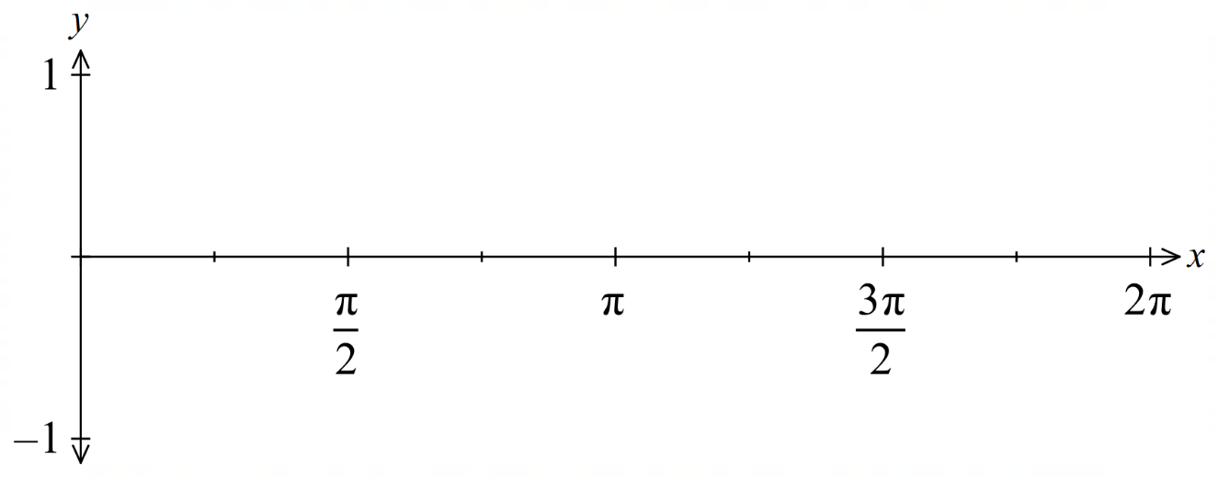
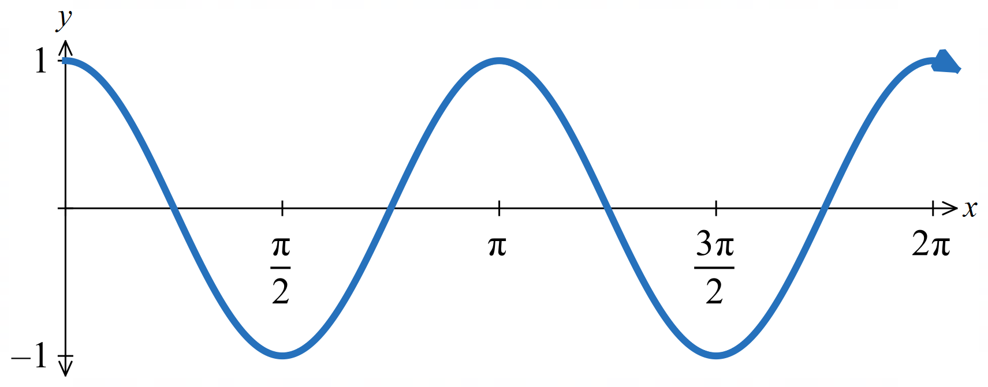

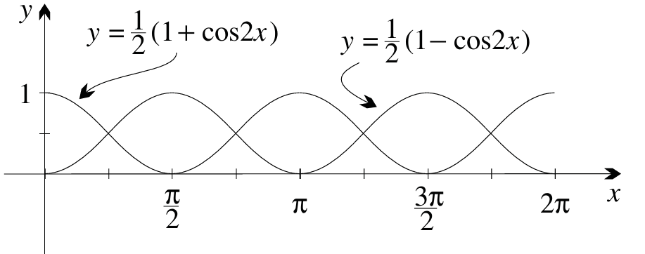
  - Using transformations, sketch on the same axis below,
$y=\frac{1}{2}\left(1+cos 2x\right)$and $y=\frac{1}{2}\left(1 - cos 2x\right)$.

  - Deduce graphically that $cos²x + sin²x = 1.$
$y =\frac{1}{2}(1 + cos 2x) = cos²x$ and $y =\frac{1}{2}(1 - cos 2x) = sin²x$.
The graphs are reflections of each other in $y =\frac{1}{2}$ and their sum equals 1 at every $x$.
∴ $cos²x + sin²x = 1.$

- Use the reverse chain rule to find:
- $\int{sin^{3}x}cos x dx$  $$\frac{1}{4}\sin^{4}x + C$$ | - $\int{sin^{6}x}cos x dx$  $$\frac{1}{7}\sin^{7}x + C$$
- $\int{cos^{5}x}sin x dx$  $$-\frac{1}{6}\cos^{6}x + C$$ | - $\int{cos^{8}x}sin x dx$  $$-\frac{1}{9}\cos^{9}x + C$$
- $\int{e^{x}}sin e^{x} dx$  $$-cos eˣ + C$$ | - $\int{e^{x}}cos \left(5e^{x}\right) dx$  $$\frac{1}{5}sin 5eˣ + C$$
- $\int{tan}x dx$  $$-\log_{e}\left|cos x\right|+ C$$ | - $\int{cot}7x dx$  $$\frac{1}{7}\log_{e}\left|sin 7x\right|+ C$$

  - Find the range of the function $y = cos x sin x$.
$$y = cos x sin x =\frac{1}{2}sin 2x, so -\frac{1}{2}≤ y ≤\frac{1}{2}$$
Integrate $y = cos x sin x$ in three ways:
  - using the $sin 2x$ formula
  - using the reverse chain rule in two different ways
  - Reconcile the three results.

$$b) \int{\frac{1}{2}}sin 2x dx = -\frac{1}{4}cos 2x + C$$

$$c) Using u = sin x: \int{cos}x sin x dx = \int{u} du =\frac{1}{2}u^{2}+ D =\frac{1}{2}sin^{2}x + D$$
$$Using u = cos x: \int{cos}x sin x dx = -\int{u} du = -\frac{1}{2}u^{2}+ E = -\frac{1}{2}cos^{2}x + E$$

d) The three constants C, D, E differ.
Using $\cos{2x}= 1 - 2 \sin^{2}x,$ we will show the first two results are equivalent:
$$-\frac{1}{4} cos 2x =\frac{1}{2} \sin^{2}x -\frac{1}{4}$$
Using $\cos{2x}= 2 \cos^{2}x - 1$, we sill show the first and third results are equivalent:
$$-\frac{1}{4} cos 2x = -\frac{1}{2} cos^{2}x +\frac{1}{4}$$
So, all three are equivalent.

Mastery

  - By writing $sin⁴x$ as $(sin²x)²$, show that $sin^{4}x =\frac{3}{8}-\frac{1}{2} cos 2x +\frac{1}{8}cos 4x$.
  - Find a similar result for $cos⁴x$.
$$a) sin⁴x = (sin²x)² = {\left(\frac{1}{2}-\frac{1}{2}cos 2x\right)}^{2}$$
$$=\frac{1}{4}-\frac{1}{2}cos 2x +\frac{1}{4}cos^{2}2x$$
$$=\frac{1}{4}-\frac{1}{2}cos 2x +\frac{1}{4}\left(\frac{1}{2}+\frac{1}{2}cos 4x\right)$$
$$=\frac{3}{8}-\frac{1}{2}cos 2x +\frac{1}{8}cos 4x$$
$$b) cos⁴x = (cos²x)² = {\left(\frac{1}{2}+\frac{1}{2}cos 2x\right)}^{2}$$
$$=\frac{1}{4}+\frac{1}{2}cos 2x +\frac{1}{4}cos^{2}2x$$
$$=\frac{3}{8}+\frac{1}{2}cos 2x +\frac{1}{8}cos 4x$$

- Find, using the Pythagorean identity:
$$\int_{0}^{\frac{π}{3}}{sin^{3}x} dx$$
$$sin³x = sin x\left(1 - cos^{2}x\right)$$
$$\int_{0}^{\frac{π}{3}}{sin^{3}x} dx = \int_{0}^{\frac{π}{3}}{sin}x\left(1 - cos^{2}x\right) dx$$
$$u =\cos{x}, du = -\sin{x}dx;$$
$$limits: x = 0, u = 1,$$
$$x =\frac{π}{3}, u =\frac{1}{2}$$
$$= -\int_{1}^{\frac{1}{2}}{\left(1 - u^{2}\right)}du = \int_{\frac{1}{2}}^{1}{\left(1 - u^{2}\right)}du = {\left[u -\frac{u^{3}}{3}\right]}_{\frac{1}{2}}^{1}$$
$$= \left(1 -\frac{1}{3}\right)- \left(\frac{1}{2}-\frac{1}{24}\right)=\frac{5}{24}$$

- Evaluate using the standard forms $\int{sec^{2}x} dx = tan x$ and $\int{cosec^{2}x} dx = -cot x$:
- $\int{tan^{2}2x} dx$  $$\int{\tan^{2}2x} dx = \int{\left(\sec^{2}2x - 1\right)}dx$$  $$=\frac{1}{2}tan 2x - x + C$$ | - $\int{cot^{2}\left(\frac{x}{2}\right) } dx$  $$\int{\cot^{2}\left(\frac{x}{2}\right)} dx = \int{\left({cosec}^{2}\left(\frac{x}{2}\right) - 1\right)}dx$$  $$= -2 cot\left(\frac{x}{2}\right) - x + C$$
- $\int_{\frac{π}{12}}^{\frac{π}{9}}{3}tan^{2}3x dx$  $$\int_{\frac{π}{12}}^{\frac{π}{9}}{3}\tan^{2}3x dx = \int_{\frac{π}{12}}^{\frac{π}{9}}{3\left(\sec^{2}3x - 1\right)}dx = {\left[tan 3x - 3x\right]}_{\frac{π}{12}}^{\frac{π}{9}}$$  $$= \left(tan\left(\frac{π}{3}\right)-\frac{π}{3}\right)- \left(tan\left(\frac{π}{4}\right)-\frac{π}{4}\right)$$  $$= \left(\sqrt{3}-\frac{π}{3}\right)- \left(1 -\frac{π}{4}\right)$$  $$= \sqrt{3}- 1 -\frac{π}{12}$$ | - $\int_{\frac{π}{24}}^{\frac{π}{8}}{cot^{2}4x} dx$  $$\int_{\frac{π}{24}}^{\frac{π}{8}}{\cot^{2}4x} dx = \int_{\frac{π}{24}}^{\frac{π}{8}}{\left({cosec}^{2}4x - 1\right)}dx = {\left[-\frac{1}{4}cot 4x - x\right]}_{\frac{π}{24}}^{\frac{π}{8}}$$  $$= \left(-\frac{1}{4}cot\left(\frac{π}{2}\right)-\frac{π}{8}\right)- \left(-\frac{1}{4}cot\left(\frac{π}{6}\right)-\frac{π}{24}\right)$$  $$= \left(0 -\frac{π}{8}\right)- \left(-\frac{\sqrt{3}}{4}-\frac{π}{24}\right)$$  $$=\frac{\sqrt{3}}{4}-\frac{π}{12}$$

- Integrate using the reverse chain rule, or otherwise:
  - $tan x sec²x$
  - $\frac{sin^{2}x}{1 + cos x}$
  - $\frac{1 + \cos^{3}x}{\cos^{2}x}$
a) $u = tan x, du = sec²x dx$
$$\int{tan}x sec^{2}x dx = \int{u} du =\frac{1}{2}u^{2}+ C =\frac{1}{2}tan^{2}x + C$$

$$b)\frac{sin^{2}x}{1 + cos x}=\frac{1 - cos^{2}x}{1 + cos x}=\frac{\left(1 - cos x\right)\left(1 + cos x\right)}{1 + cos x}= 1 - cos x$$
$$\int{\left(1 - cos x\right)}dx = x - sin x + C$$

$$c)\frac{1 + cos^{3}x}{cos^{2}x} = sec²x + cos x$$
$$\int{\left(sec^{2}x + cos x\right)}dx = tan x + sin x + C$$

